

**Network Security**

Year 2/3 (2025/26), Semester 3/5

**SCHOOL OF INFOCOMM TECHNOLOGY**

Diploma in Cybersecurity & Digital Forensics

**ASSIGNMENT**

**Duration:**  Weeks 5 -17

**Weightage:**   40%

Business Requirement Analysis and Detailed Firewall Comparisons 4

Business Requirements Analysis 5

Firewall Solution Comparison 5

Recommendation : Why Palo Alto Networks is Preferred 6

Network Diagram of Canes Pte. Ltd. 8

Technical Implementations 8

1. Zone Configuration for SG and KL Offices 9

Overview of Zone Configuration 9

SG Office 9

KL Office 9

10

2. Virtual Network Adapter Setup and IP Address Assignment 10

SG Office 11

Interfaces and IP Address Configuration 11

Static Routing 11

KL Office 11

Static Routing 12

3. Network Traffic Policies for Departments 12

SG Office 13

KL Office 14

4. Application Identification (App-ID) Implementation 15

SG Office 16

KL Office 18

5. Traffic Decryption Policies 21

SG Office 22

KL Office 26

7. LinkedIn Access Control by Department 31

HR department: Access LinkedIn allowed; LinkedIn Messaging blocked. 31

Sales and IT departments: No access to LinkedIn. 31

8. Facebook Access Control by Department 33

HR and Sales departments: Access Facebook allowed; Facebook Chat blocked. 33

IT department: No access to Facebook. 33

9. Restriction on Online Storage Services 34

SG Office 34

KL Office 37

10. Secure LAN-to-LAN VPN Connection Setup 38

VPN Tunnel design 39

Configuration Steps 39

11. IDS/IPS 52

Antivirus 53

Singapore and KL Office 53

File Blocking 55

Singapore Office 56

KL Office 56

DOS Protection 57

Testing & Results 59

Network Traffic Policies for Departments 60

SG HR Department (192.168.10.10) 60

Web Traffic 60

DNS Traffic 61

Email Traffic 61

SG IT Department (192.168.20.10) 63

Web Traffic 64

DNS Traffic 64

Email Traffic 64

Remote Access (RDP) 64

KL Sales Department (192.168.30.10) 65

App-ID Implementation 69

SG Office 70

KL Office 71

Traffic Decryption Policies 72

SG Office 73

KL Office 75

LinkedIn Access Control 75

Facebook Access Control 77

Restriction on Online Storage Services 78

SG Office 79

KL Office 79

VPN Connection 80

SG Office 81

KL Office 81

IPS/IDS 82

Antivirus 83

File Blocking 83

KL Office 85

Antivirus 86

File Blocking 86

DOS Protection 87

Geo-IP Blocking 89

Conclusions and Recommendations 89

Appendix A: Individual Contribution by Each Team Member 89

# Business Requirement Analysis and Detailed Firewall Comparisons

## Business Requirements Analysis

**Canes Pte. Ltd.**, a multinational corporation with offices in Singapore and Kuala Lumpur, requires a secure, scalable, and efficient network infrastructure to support its key business operations across departments such as Human Resources (HR), Information Technology (IT), and Sales. As the company grows, it is critical to ensure that both internal and external communications remain secure, while also providing granular control and visibility over user and application traffic.

The high-level business requirements are as follows:

* **Data Protection**: Sensitive data, particularly from HR and Sales, must be safeguarded from external threats and potential internal misuse. The company requires next-generation firewall capabilities with advanced threat detection and prevention mechanisms.
* **Network Segmentation**: Departments must be logically separated using zones to minimize the impact of security incidents and to enforce department-specific access control policies.
* **Application Visibility and Control**: Employees access a wide range of cloud services. The company must be able to identify and control the use of approved applications while blocking high-risk or unauthorized ones.
* **Remote Access and VPN Connectivity**: Encrypted VPN tunnels are essential to ensure secure communication and centralized resource access between the Singapore and Kuala Lumpur offices, enabling the safe exchange of confidential data.

## Firewall Solution Comparison

A comparative evaluation of three leading next-generation firewall (NGFW) solutions was conducted: Palo Alto Networks NGFW, Fortinet FortiGate, and Cisco Firepower. The table below summarizes how each solution meets the core requirements:

|  |  |  |  |
| --- | --- | --- | --- |
| *Feature***/**Requirement | **Palo Alto NGFW** | **Fortinet FortiGate** | **Cisco Firepower** |
| *App-ID / App Control* | Yes (Industry-leading) | **Yes** | **Basic, not as granular** |
| *User-ID Integration (AD)* | Yes | Yes | Requires configuration |
| *SSL Decryption* | Flexible and selective | Yes | Limited per policy |
| *Threat Intelligence* | Wildfire + ThreatDB | FortiGuard | Talos |
| *Site-to-Site VPN* | IKEv2/IPSec | IKEv2/IPSec | IKEv2/IPSec |
| *Policy Management Interface* | Panorama + an intuitive GUI | Slightly complex | Requires FMC |
| *Log & Event Monitoring* | Detailed + Correlated | Not as detailed | Good but not as intuitive as PA |
| *Licensing Complexity* | Simple and Straightforward | More bundled tiers | Feature fragmentation |

## Recommendation : Why Palo Alto Networks is Preferred

After a comprehensive evaluation, **Palo Alto Networks** emerges as the preferred firewall solution for Canes Pte. Ltd. due to its strong alignment with the company’s security and operational requirements.

Key advantages include:

* **Advanced Application and User Control**  
  Palo Alto's **App-ID and User-ID technologies** offer deep insight into application usage and enable granular access policies. For example, HR can be allowed access to LinkedIn while restricting its messaging features, or Sales can be blocked from using unauthorized file-sharing platforms.
* **Robust Threat Prevention**  
  With **WildFire** and **ThreatDB**, Palo Alto delivers real-time threat intelligence and sandboxing, enabling proactive defense against zero-day threats.
* **Flexible SSL Decryption**  
  Its support for **selective SSL decryption** allows secure inspection of encrypted traffic while respecting privacy regulations through exclusions.
* **Reliable VPN Connectivity**  
  Stable and secure site-to-site **VPN connections** between Singapore and Kuala Lumpur ensure uninterrupted and encrypted communication across offices.
* **Intuitive Management and Monitoring**  
  The management interface is **user-friendly** and, when paired with Panorama, allows for centralized policy control and comprehensive visibility across the network.
* **Consistent Performance**  
  Palo Alto firewalls are engineered to maintain high throughput and low latency, even when advanced features like App-ID and SSL inspection are enabled.

Palo Alto Networks provides the most complete and business-aligned solution among the evaluated options. Its combination of advanced security capabilities, ease of management, and performance efficiency make it the optimal choice to meet the current and future network security needs of Canes PTE LTD.

# Network Diagram of Canes Pte. Ltd.

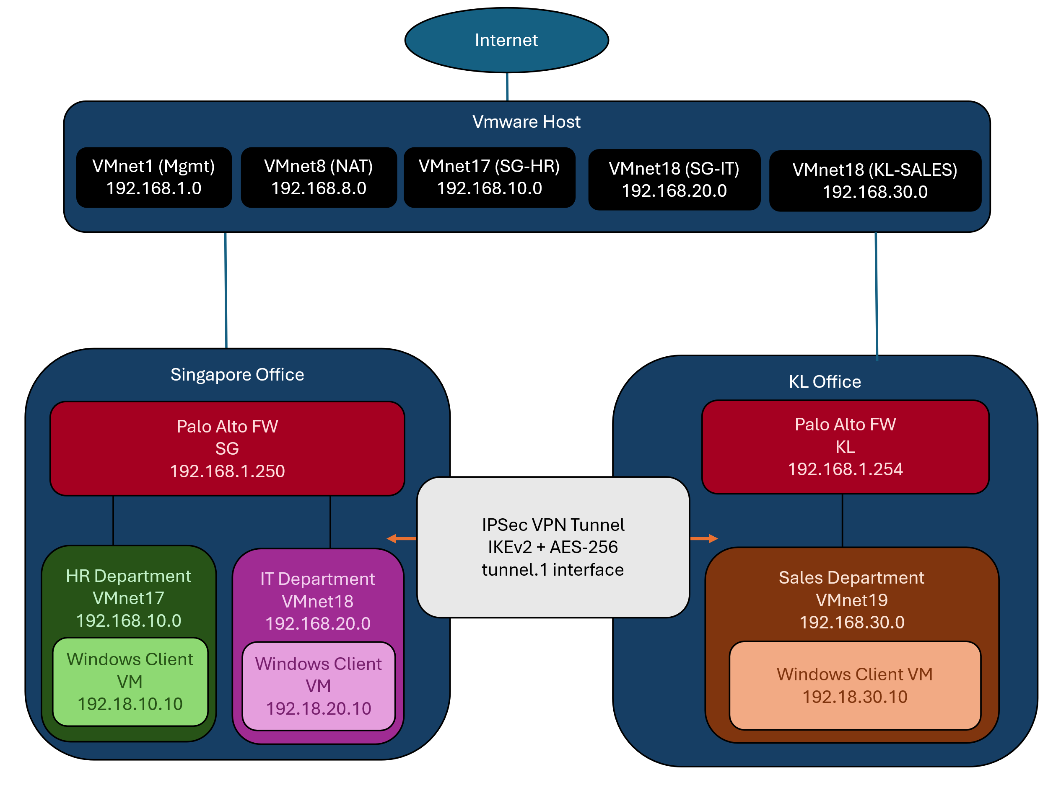

# Technical Implementations

## 1. Zone Configuration for SG and KL Offices

A zone in a firewall is a logical segmentation used to control traffic flow and apply security policies. By grouping interfaces into zones, network administrators can enforce different levels of trust, monitor inter-zone traffic, and reduce attack surfaces easily.

All zones in the configurations are Layer 3, this means that:

* All interfaces have individual IP addresses
* Routing is enabled
* Security policies are applied between zones

Separation of internal zones allow implementation of firewall policies. The Untrust zone acts as a boundary to the public network, ensuring that traffic from external sources is inspected before accessing internal resources.

The SG and KL offices have implemented a zone-based Layer 3 configuration using dedicated interfaces. This design provides strong security boundaries, department-level segmentation, and centralized policy enforcement. The setup also allows efficient monitoring, improved threat mitigation, and scalability for future expansion.

### Overview of Zone Configuration

#### SG Office

|  |  |  |
| --- | --- | --- |
| Zone Name | Zone Type | Interface Assigned |
| HR_Zone | Layer 3 | ethernet1/2 |
| IT_Zone | Layer 3 | ethernet1/3 |
| Untrust | Layer 3 | ethernet1/1 |

HR_Zone and IT_Zone represent separate internal departments, each mapped to their dedicated interfaces. Untrust zone on ethernet1/1 serves as the eternal interface, receiving traffic from outside.

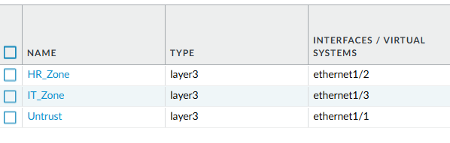

#### KL Office

|  |  |  |
| --- | --- | --- |
| Zone Name | Zone Type | Interface Assigned |
| Sales_Zone | Layer 3 | ethernet1/2 |
| Untrust | Layer 3 | ethernet1/1 |

Sales_Zone is the only internal zone, mapped to ethernet1/2. Similar to SG, Untrust is assigned to ethernet1/1

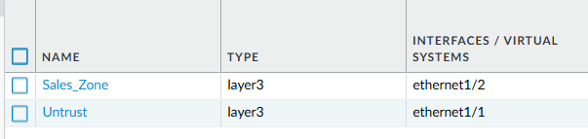

### 

## 2. Virtual Network Adapter Setup and IP Address Assignment

This section outlines the interface configuration, IP addressing, and static routing implemented for the SG and KL offices. The configuration facilitates inter-zone routing, internet access, and structured network segmentation using virtual routers and Layer 3 interfaces.

Each individual office has their own virtual routers which are used to handle routing between zones and out to external networks.

The SG and KL offices are equipped with Layer 3 interfaces mapped to logical zones and connected to virtual routers. Each site implements static default routing to route outbound traffic to the internet gateway. This configuration ensures reliable connectivity, maintains security boundaries, and simplifies traffic management.

### SG Office

#### Interfaces and IP Address Configuration

|  |  |  |  |  |
| --- | --- | --- | --- | --- |
| **Interface** | **Type** | **IP Address** | **Virtual Router** | **Zone** |
| ethernet1/1 | Layer 3 | 192.168.8.10/24 | VR-SG | Untrust |
| ethernet1/2 | Layer 3 | 192.168.101.1/24 | VR-SG | HR_Zone |
| ethernet1/3 | Layer 3 | 192.168.201.1/24 | VR-SG | IT_Zone |

* Each interface is configured with a /24 subnet
* The internal departments HR and IT are logically separated by assigning dedicated IP subnets and zones
* All interfaces are assigned to the virtual router VR-SG

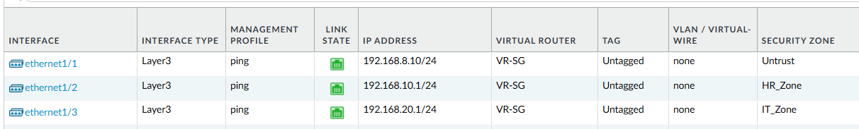

#### Static Routing

A default route (0.0.0.0/0) is configured to allow all outbound traffic from the internal zones to reach external zones:

* Destination : 0.0.0.0/0
* Interface : ethernet1/1 (Untrust)
* Next Hop : 192.168.8.2 (default gateway IP for VMnet8 – NAT)

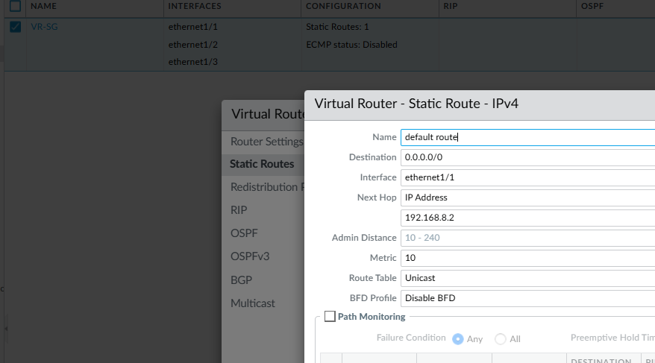

KL Office

Interfaces and IP Address Configuration

|  |  |  |  |  |
| --- | --- | --- | --- | --- |
| **Interface** | **Type** | **IP Address** | **Virtual Router** | **Zone** |
| ethernet1/1 | Layer 3 | 192.168.8.10/24 | VR-KL | Untrust |
| ethernet1/2 | Layer 3 | 192.168.30.1/24 | VR-KL | Sales_Zone |

* The KL office has a simpler setup with two zones, one internal (Sales) and one external (Untrust)
* Each interface has a unique IP subnet and is connected to the virtual router VR-KL

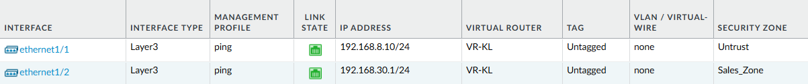

#### Static Routing

Like the SG Office, a default route is defined to manage internet-bound traffic:

* Destination : 0.0.0.0/0
* Interface : ethernet1/1 (Untrust)
* Next Hop : 192.168.8.2 (default gateway IP for VMnet8 – NAT)

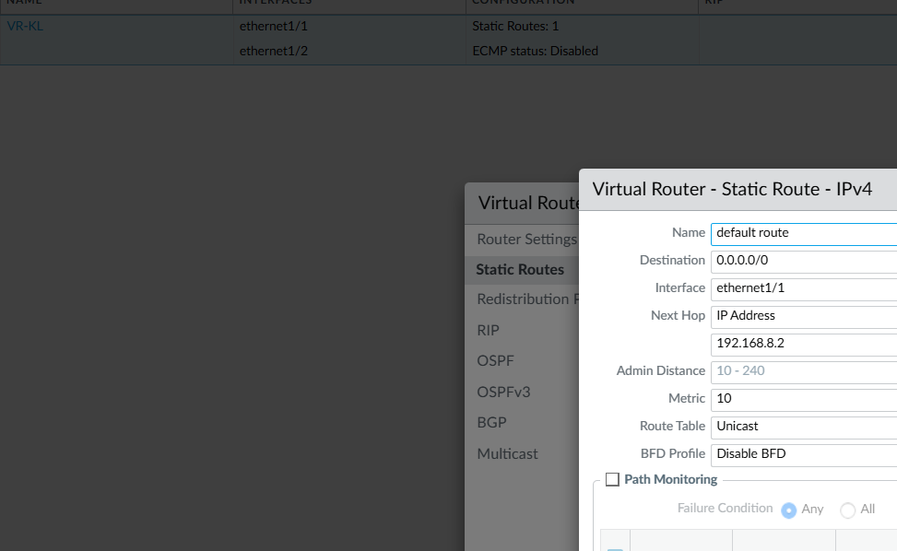

## 3. Network Traffic Policies for Departments

This section outlines the firewall security policies applied to departmental network zones to control and permit essential outbound traffic. The configuration ensures that users in HR, IT, and Sales departments have secure and functional access to external services required for daily business operations.

* All policies follow a Zone-Based Firewall model.
* Policies are configured to allow specific application types from internal zones (e.g., HR_Zone, IT_Zone, Sales_Zone) to the Untrust zone (internet).
* Policies are grouped by department and allow web, email, DNS, and remote access traffic.
* NAT (Network Address Translation) is applied to enable private IPs to access public internet resources.

### SG Office

|  |  |  |  |
| --- | --- | --- | --- |
| **Policy Name** | **Source Zone** | **Destination Zone** | **Applications / Services Allowed** |
| Allow_Web_Traffic_HRIT | HR_Zone, IT_Zone | Untrust | SSL, Web Browsing |
| Allow_DNS_HRIT | HR_Zone, IT_Zone | Untrust | DNS, DNS-over-HTTPS |
| Allow_Email_HRIT | HR_Zone, IT_Zone | Untrust | IMAP, POP3, SMTP, SSL |
| Allow_Remote_Access_HRIT | HR_Zone, IT_Zone | Untrust | SSH, MS-RDP |
| **Allow_HR_to_Internet** | HR_Zone | Untrust | Any |
| **Allow_IT_to_Internet** | IT_Zone | Untrust | Any |

|  |  |  |  |  |
| --- | --- | --- | --- | --- |
| **NAT Rule Name** | **Source Zone** | **Destination Zone** | **Translated Source** | **Interface** |
| HR_NAT | HR_Zone | Untrust | Dynamic IP and Port | ethernet1/1 |
| IT_NAT | HR_Zone | Untrust | Dynamic IP and Port | ethernet1/1 |

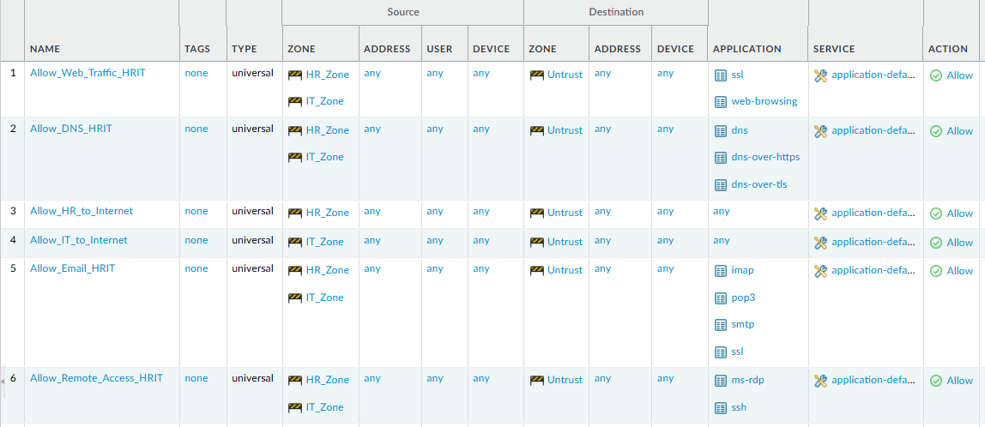

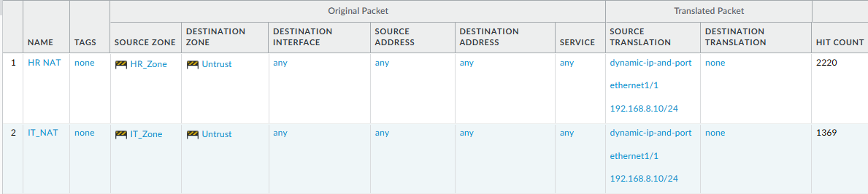

### KL Office

|  |  |  |  |
| --- | --- | --- | --- |
| **Policy Name** | **Source Zone** | **Destination Zone** | **Applications / Services Allowed** |
| Allow_Web_Traffic_Sales | Sales_Zone | Untrust | SSL, Web Browsing |
| Allow_DNS_Sales | Sales_Zone | Untrust | DNS, DNS-over-HTTPS |
| Allow_Email_Sales | Sales_Zone | Untrust | IMAP, POP3, SMTP, SSL |
| Allow_Remote_Access_Sales | Sales_Zone | Untrust | SSH, MS-RDP |
| Allow_Sales_to_Internet | Sales_Zone | Untrust | Any |

|  |  |  |  |  |
| --- | --- | --- | --- | --- |
| **NAT Rule Name** | **Source Zone** | **Destination Zone** | **Translated Source** | **Interface** |
| SALES_NAT | HR_Zone | Untrust | Dynamic IP and Port | ethernet1/1 |

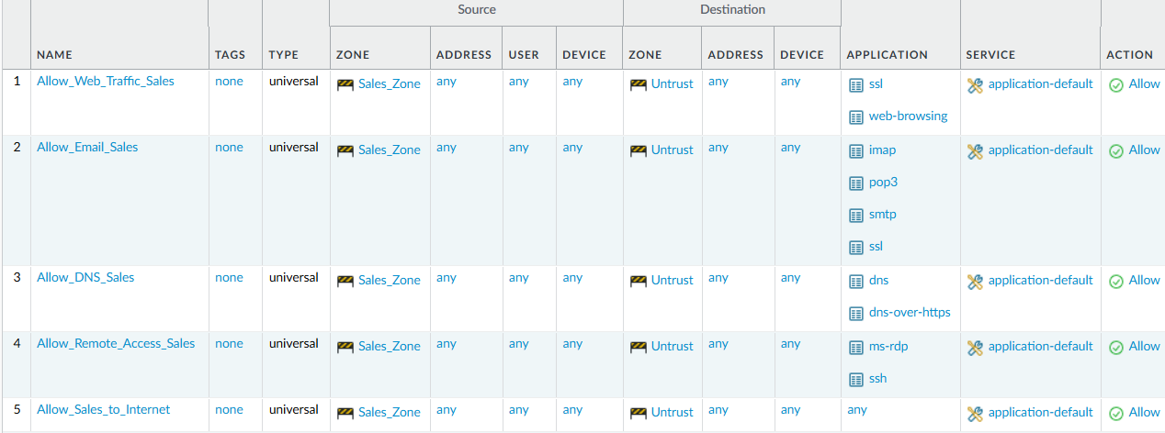

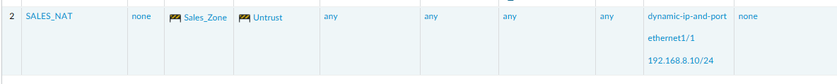

## 4. Application Identification (App-ID) Implementation

To configure security policies to allow standard applications and block unapproved applications in Singapore office from HR Zone and IT Zone to the Untrusted zone and in KL office from Sales Zone to the untrusted zone.

### SG Office

Step 1: Create a Security Policy to Allow Standard Applications

1. Go to **Policies > Security**.
2. Click **Add** to create a new policy.
3. In the **General** tab:
   1. **Name**: Allow_Standard_Apps
4. In the **Source** tab:
   1. **Source Zone**: HR_Zone, IT_Zone
   2. **Source Address**: any
   3. **Source User**: any
5. In the **Destination** tab:
   1. **Destination Zone**: Untrust
   2. **Destination Address**: any
6. In the **Application** tab:
   1. Add the following applications:
      1. google-base
      2. ms-office365-base
      3. ms-update
      4. outlook-web
      5. paloalto-updates
      6. quic
      7. ssl
7. In the **Service/URL Category** tab:
   1. Service: application-default
8. In the **Actions** tab:
   1. Action: Allow
9. Click **OK**.

Step 2: Create a Security Policy to Block All Other Applications

1. Go to Policies > Security.
2. Click Add to create another policy.
3. In the General tab:
   1. Name: Block_Unapproved_Apps
4. In the Source tab:
   1. Source Zone: HR_Zone, IT_Zone
   2. Source Address: any
   3. Source User: any
5. In the Destination tab:
   1. Destination Zone: Untrust
   2. Destination Address: any
6. In the Application tab:
   1. Application: any
7. In the Service/URL Category tab:
   1. Service: application-default
8. In the Actions tab:
   1. Action: Deny
9. Click OK.

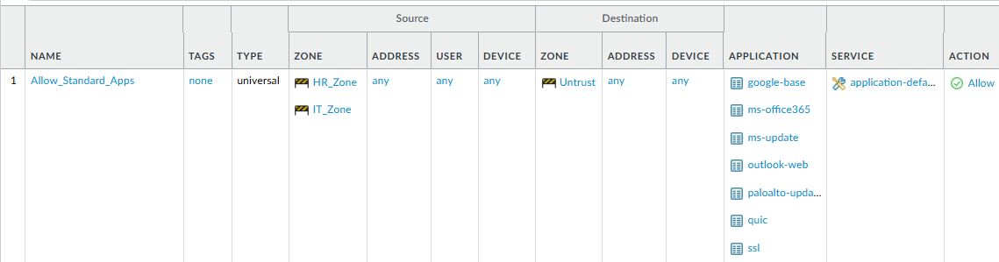 

### KL Office

Step 1: Create a Security Policy to Allow Standard Applications

1. Go to **Policies > Security**.
2. Click **Add** to create a new policy.
3. In the **General** tab:
   1. **Name**: Allow_Standard_Apps
4. In the **Source** tab:
   1. **Source Zone**: Sales_Zone
   2. **Source Address**: any
   3. **Source User**: any
5. In the **Destination** tab:
   1. **Destination Zone**: Untrust
   2. **Destination Address**: any
6. In the **Application** tab:
   1. Add the following applications:
      1. google-base
      2. ms-office365-base
      3. ms-update
      4. outlook-web
      5. paloalto-updates
      6. quic
      7. ssl
7. In the **Service/URL Category** tab:
   1. Service: application-default
8. In the **Actions** tab:
   1. Action: Allow
9. Click **OK**.

Step 2: Create a Security Policy to Block All Other Applications

1. Go to Policies > Security.
2. Click Add to create another policy.
3. In the General tab:
   1. Name: Block_Unapproved_Apps
4. In the Source tab:
   1. Source Zone: Sales_Zone
   2. Source Address: any
   3. Source User: any
5. In the Destination tab:
   1. Destination Zone: Untrust
   2. Destination Address: any
6. In the Application tab:
   1. Application: any
7. In the Service/URL Category tab:
   1. Service: application-default
8. In the Actions tab:
   1. Action: Deny
9. Click OK.

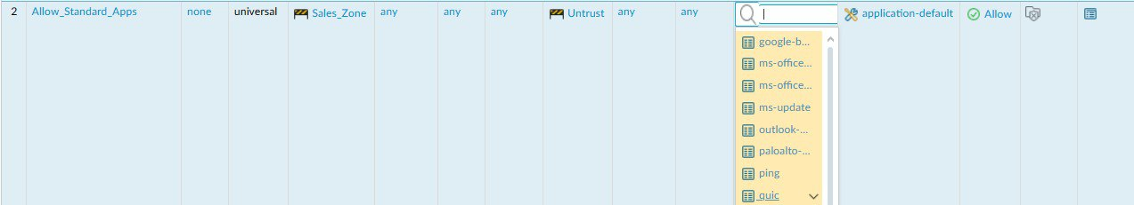



## 5. Traffic Decryption Policies

To implement SSL decryption on the Singapore and KL Office firewall:

* Exclude banking websites from decryption.
* Decrypt all other SSL traffic.

### SG Office

Step 1: Create a Self-Signed Root Certificate

1. Go to Device > Certificate Management > Certificates.
2. Click Generate to create a new certificate:
   1. Certificate Name: ssl-cert
   2. Common Name: 192.168.1.250
   3. Tick the box for Certificate Authority
   4. Leave other fields as default.
3. Click Generate.
4. After generating, click on the ssl-cert entry to edit.
5. Tick the following options:
   1. Forward Trust Certificate
   2. Forward Untrust Certificate
   3. Trusted Root CA Certificate
6. Click OK to save changes.



Step 2: Create a Custom URL Category for Financial Sites

1. Go to Objects > Custom Objects > URL Category.
2. Click Add to create a new category:
   1. Name: Financial Sites
   2. Type: URL List
   3. Sites to include:
      1. www.dbs.com
      2. www.posb.com.sg
      3. www.ocbc.com
      4. www.uob.com.sg
      5. www.hsbc.com.sg
      6. www.citibank.com.sg
      7. (and any other relevant banking sites)
3. Click OK.

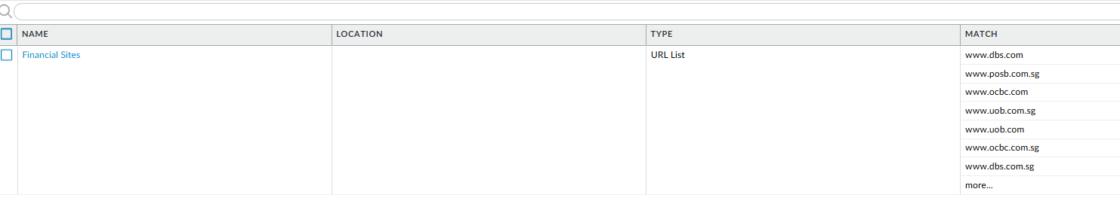

Step 3: Create Decryption Policy to Bypass Financial Sites

1. Go to Policies > Decryption.
2. Click Add to create a new policy:
   1. Name: nodecrypt_banking
3. In the Source tab:
   1. Source Zone: HR_Zone, IT_Zone
4. In the Destination tab:
   1. Destination Zone: Untrust
5. In the URL Category tab:
   1. Add: Financial Sites
6. In the Options tab:
   1. Action: no-decrypt
   2. Type: SSL Forward Proxy
   3. Log Successful SSL Handshake: true
   4. Log Unsuccessful SSL Handshake: true
7. Click OK.

Step 4: Create Decryption Policy for All Other Traffic

1. Click Add to create another decryption policy:
   1. Name: decrypt_all
2. In the Source tab:
   1. Source Zone: HR_Zone, IT_Zone
3. In the Destination tab:
   1. Destination Zone: Untrust
4. In the URL Category tab:
   1. Ensure Any is selected.
5. In the Options tab:
   1. Action: decrypt
   2. Type: SSL Forward Proxy
   3. Log Successful SSL Handshake: true
   4. Log Unsuccessful SSL Handshake: true
6. Click OK.

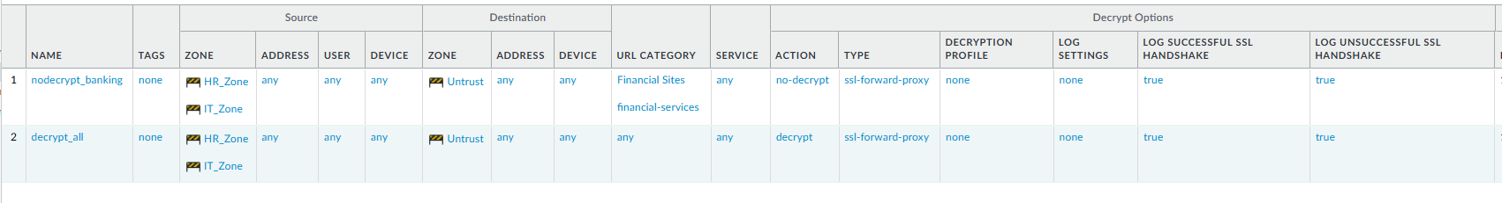

Step 5: Export Certificate and Import into VM

1. On the firewall, go to Device > Certificate Management > Certificates.
2. Select the ssl-cert, click Export Certificate.
3. Transfer the .cer file to your Windows VM.
4. On the Windows VM:
   1. Double-click the .cer file.
   2. Click Install Certificate.
   3. Choose Local Machine, click Next.
   4. Choose: Place all certificates in the following store
      1. Select Trusted Root Certification Authorities.
   5. Click Next > Finish.
   6. Restart the browser or VM.

### KL Office

Step 1: Create a Self-Signed Root Certificate

1. Go to Device > Certificate Management > Certificates.
2. Click Generate to create a new certificate:
   1. Certificate Name: ssl-cert
   2. Common Name: 192.168.1.254
   3. Tick the box for Certificate Authority
   4. Leave other fields as default.
3. Click Generate.
   1. After generating, click on the ssl-cert entry to edit.
4. Tick the following options:
   1. Forward Trust Certificate
   2. Forward Untrust Certificate
   3. Trusted Root CA Certificate
5. Click OK to save changes.

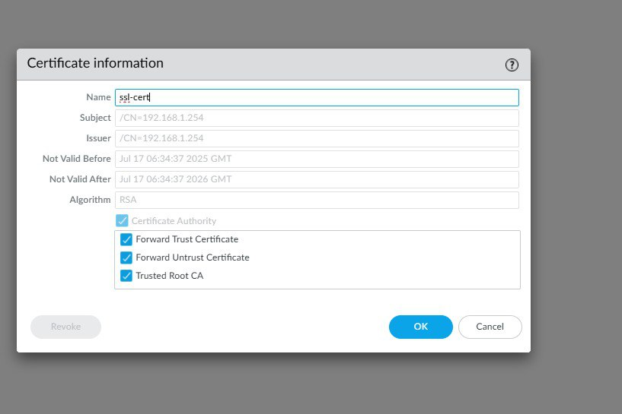

Step 2: Create a Custom URL Category for Financial Sites

1. Go to Objects > Custom Objects > URL Category.
2. Click Add to create a new category:
   1. Name: Financial Sites
   2. Type: URL List
   3. Sites to include:
      1. maybank2u.com.my
      2. uob.com.my
      3. ocbc.com.my
3. Click OK.

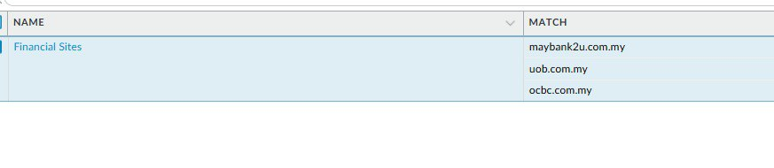

Step 3: Create Decryption Policy to Bypass Financial Sites

1. Go to Policies > Decryption.
2. Click Add to create a new policy:
   1. Name: nodecrypt_banking
3. In the Source tab:
   1. Source Zone: Sales_Zone
4. In the Destination tab:
   1. Destination Zone: Untrust
5. In the URL Category tab:
   1. Add: Financial Sites
6. In the Options tab:
   1. Action: no-decrypt
   2. Type: SSL Forward Proxy
   3. Log Successful SSL Handshake: true
   4. Log Unsuccessful SSL Handshake: true
7. Click OK.

Step 4: Create Decryption Policy for All Other Traffic

1. Click Add to create another decryption policy:
   1. Name: decrypt_all
2. In the Source tab:
   1. Source Zone: Sales_Zone
3. In the Destination tab:
   1. Destination Zone: Untrust
4. In the URL Category tab:
   1. Ensure Any is selected.
5. In the Options tab:
   1. Action: decrypt
   2. Type: SSL Forward Proxy
   3. Log Successful SSL Handshake: true
   4. Log Unsuccessful SSL Handshake: true
6. Click OK.

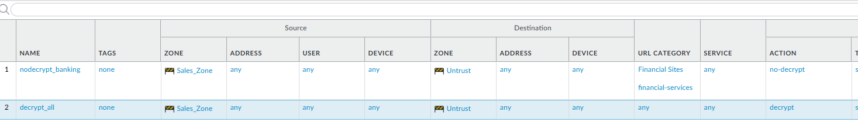

Step 5: Export Certificate and Import into VM

1. On the firewall, go to Device > Certificate Management > Certificates.
2. Select the ssl-cert, click Export Certificate.
3. Transfer the .cer file to your Windows VM.
4. On the Windows VM:
   1. Double-click the .cer file.
   2. Click Install Certificate.
   3. Choose Local Machine, click Next.
   4. Choose: Place all certificates in the following store
      1. Select Trusted Root Certification Authorities.
   5. Click Next > Finish.
   6. Restart the browser or VM.

## 7. LinkedIn Access Control by Department

### HR department: Access LinkedIn allowed; LinkedIn Messaging blocked.

### Step 1: In Palo Alto, under policies > security, configure the following policies.

|  |  |  |  |
| --- | --- | --- | --- |
| **Policy Name** | **Source Zone** | **Destination Zone** | **Applications / Services Allowed/Denied** |
| HR_Linkedin_Allow | HR_Zone | Untrust | LinkedIn  LinkedIn-base |
| HR_LinkedInBlockMsg | HR_Zone | Untrust | LinkedIn-apps  LinkedIn-editing  LinkedIn-intro  LinkedIn-mail  LinkedIn-posting  LinkedIn-uploading |
| IT_LinkedinBlock | IT_Zone | Untrust | Linkedin  Linkedin-apps  Linkedin-base  Linkedin-mail  Linkedin-posting |



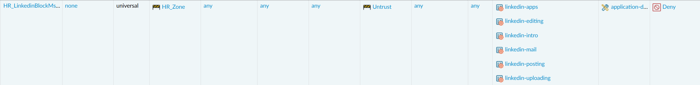

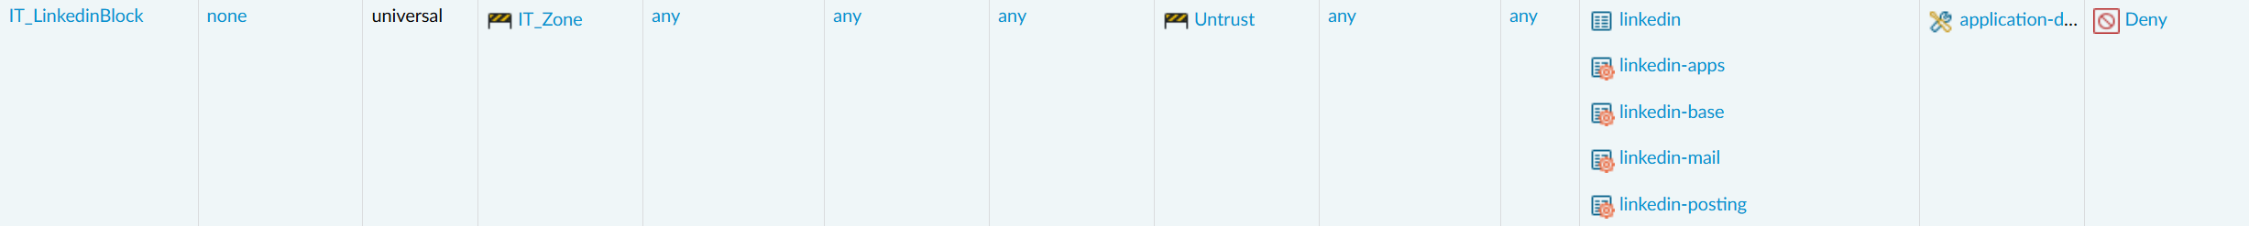

### Step 2: Commit the policies.

### Step 3: Ensure that the policies are working.

### Sales and IT departments: No access to LinkedIn.

### For Sales and IT departments, configure the policy

### In KL,

|  |  |  |  |
| --- | --- | --- | --- |
| **Policy Name** | **Source Zone** | **Destination Zone** | **Applications / Services Denied** |
| Sales_Linkedin_Deny | Sales_Zone | Untrust | Linkedin  Linkedin-apps  Linkedin-base  Linkedin-mail  Linkedin-posting |

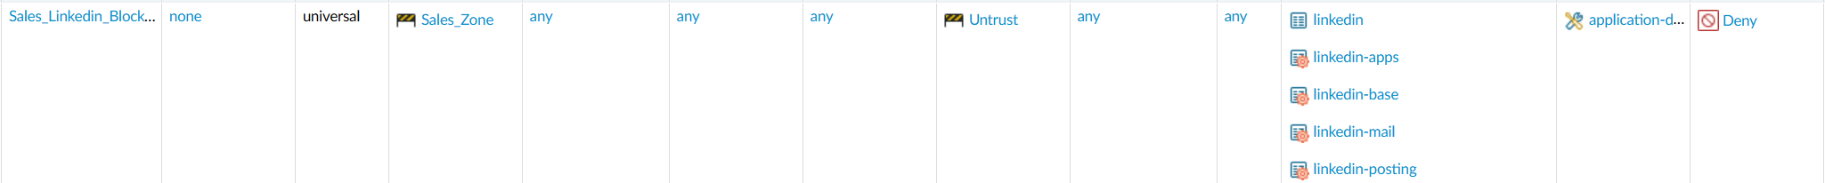

### After committing, when you try to attempt to access LinkedIn, you won’t be able to.

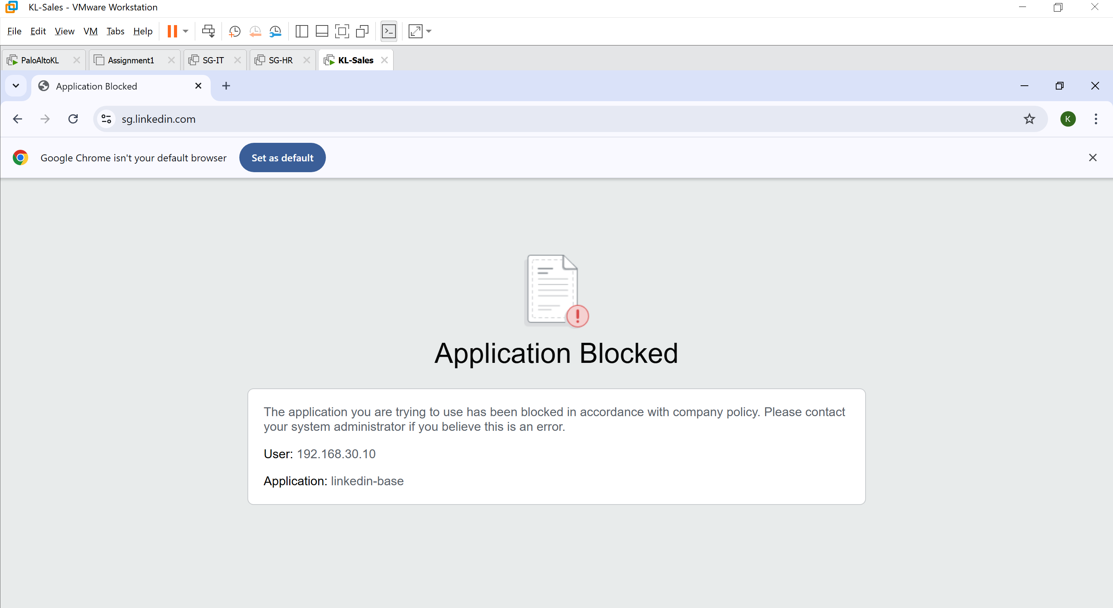

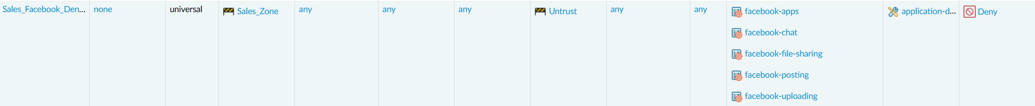

### For Singapore’s Palo Alto, since IT is also not allowed to access LinkedIn, repeat the same process. For HR, configure the following policies in Palo Alto.

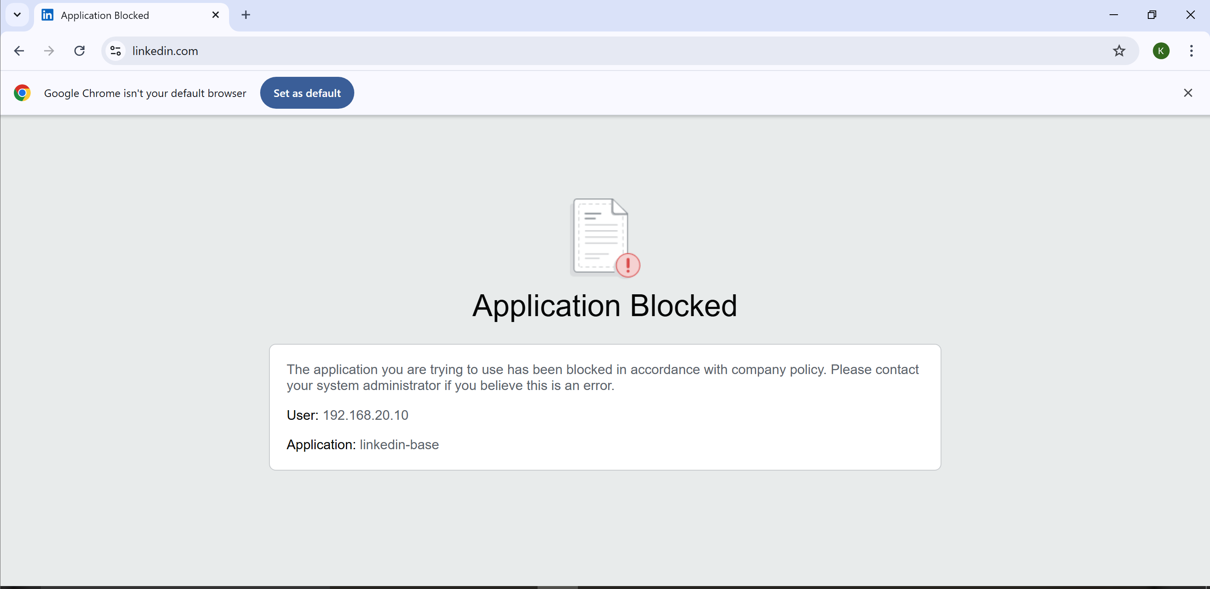

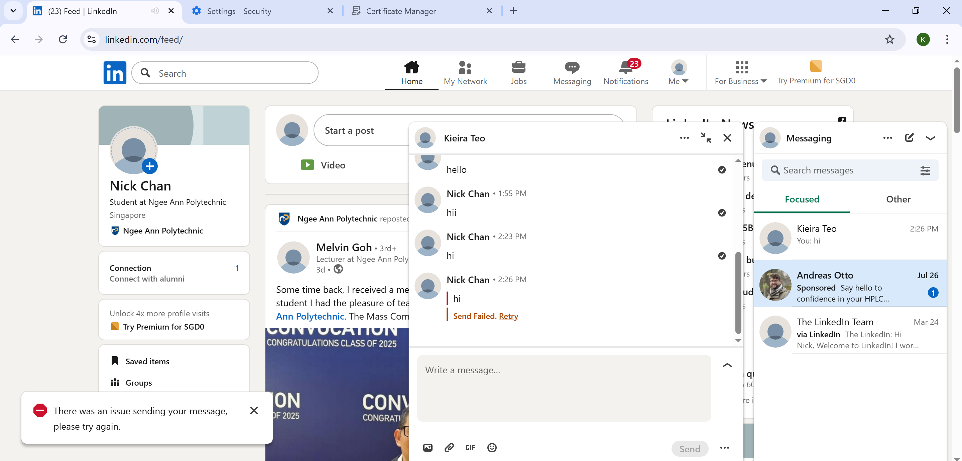

## 8. Facebook Access Control by Department

### HR and Sales departments: Access Facebook allowed; Facebook Chat blocked.

### IT department: No access to Facebook.

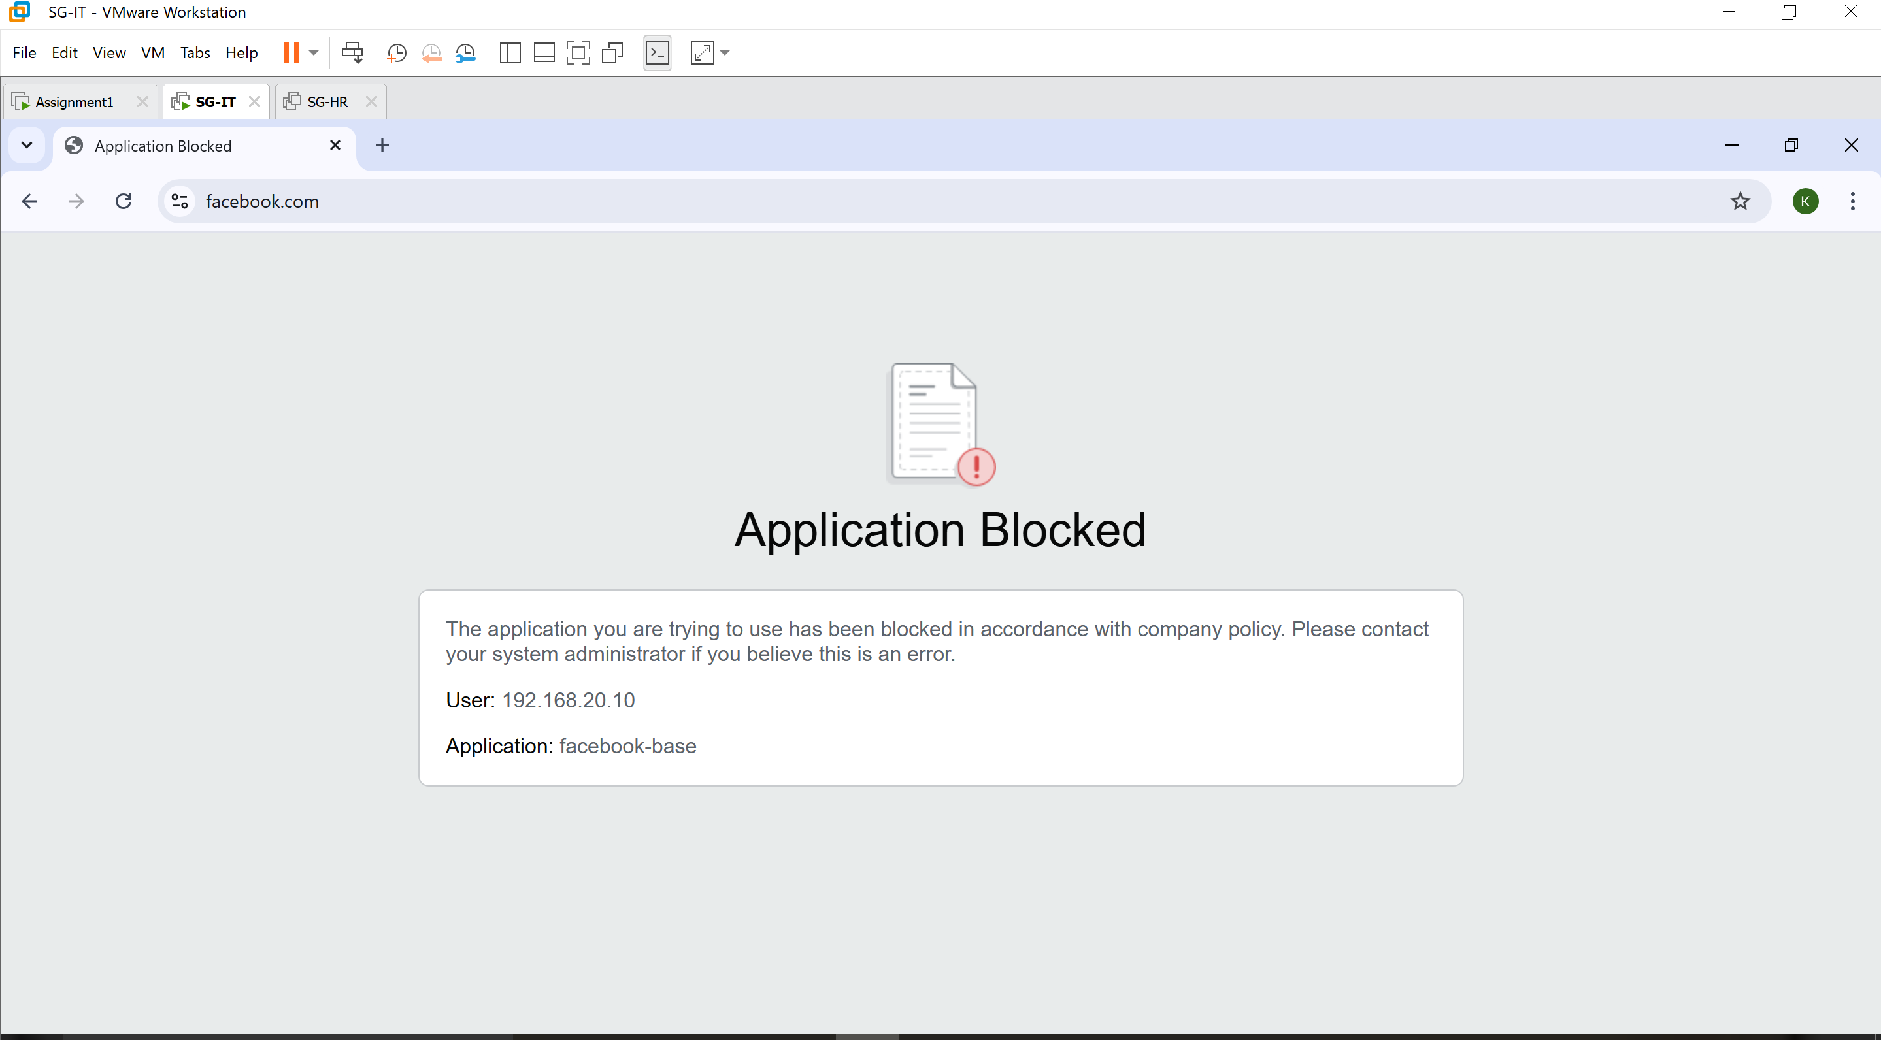

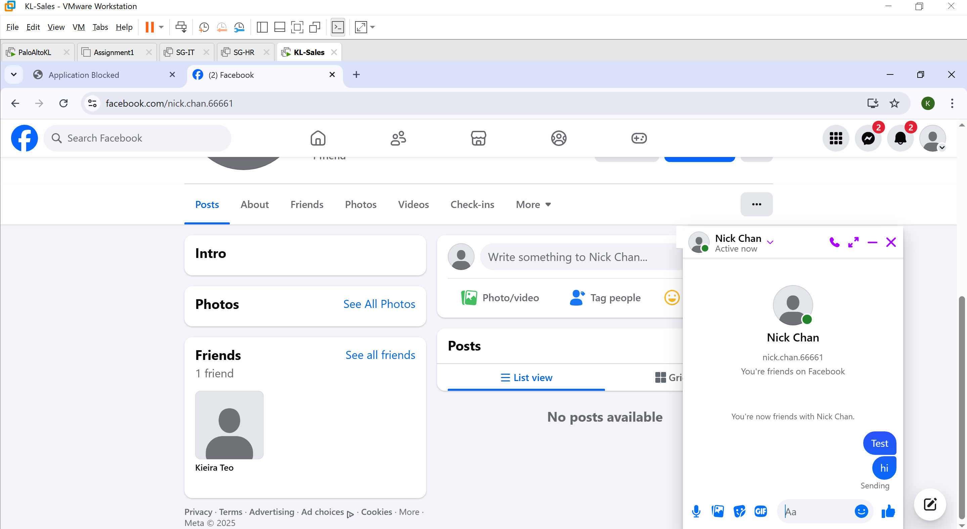

## 9. Restriction on Online Storage Services

Deny access to online storage services (e.g., Google Drive, OneDrive) for HR and Sales departments to prevent data loss.

### SG Office

Step 1:

From Objects > Application Groups, click Add.

Name: online-storage-services

Add google-drive-web, boxnet, dropbox, mega, ms-onedrive, icloud, and google-cloud-storage to the group.

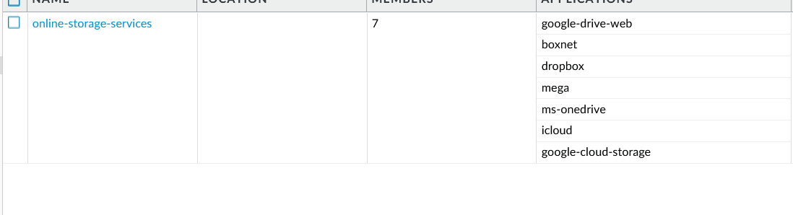

Step 2:

From Policies > Security, add a new rule:

Name: Allow_Online_Storage_IT

Source Zone: IT_Zone

Destination Zone: Untrust

Application: Set this to the online-storage-services group that you created earlier.

Service: application-default

Action: Allow

Leave the other options in the Actions tab unchanged.

Click OK to save and exit the rule.

Place the rule above Block_Unapproved_Apps.

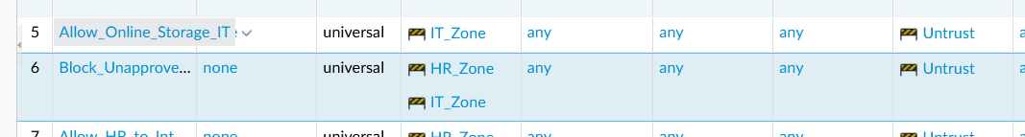

Step 3:

Clone the newly created rule.

Set the rule order to Before Rule.

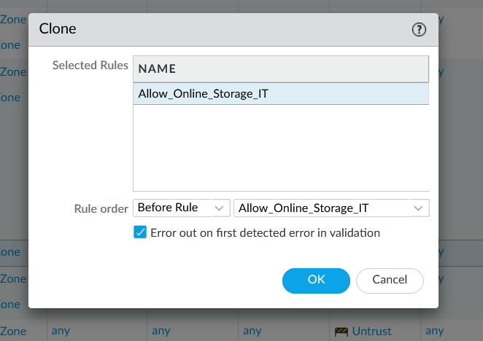

Rename it to Block_Online_Storage_HR.

Change the source zone to HR_Zone, and change the action to Deny.

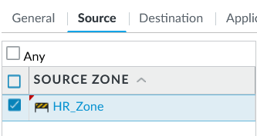

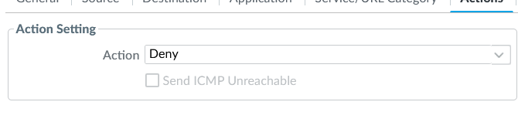Commit the changes.

### KL Office

Repeat the previous instructions to create the rule Block_Online_Storage_KL.

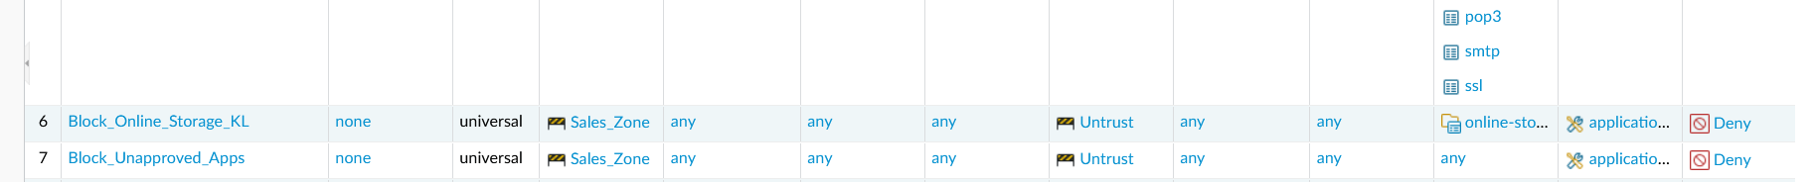

## 10. Secure LAN-to-LAN VPN Connection Setup

### VPN Tunnel design

|  |  |  |
| --- | --- | --- |
| Location | Subnet | Firewall Tunnel IP |
| SG Office | 192.168.10.0/24 (HR), 192.168.20.0/24 (IT) | 10.10.10.1 |
| KL Office | 192.168.30.0/24 (Sales) | 10.10.10.2 |

VPN Type: IPSec Tunnel (IKEv2)

Encryption: AES-256 + SHA-256

Key exchange: Pre-Shared Key

Tunnel interface: tunnel.1

Routing: static routes via tunnel.1 to reach more remote subnets.

### Configuration Steps

Step 0)

* Create VPN_Zone in Network > Zones > Add
  + Name: VPN_Zone
  + Type: Layer 3
  + Do it for both SG and KL
  + Then commit

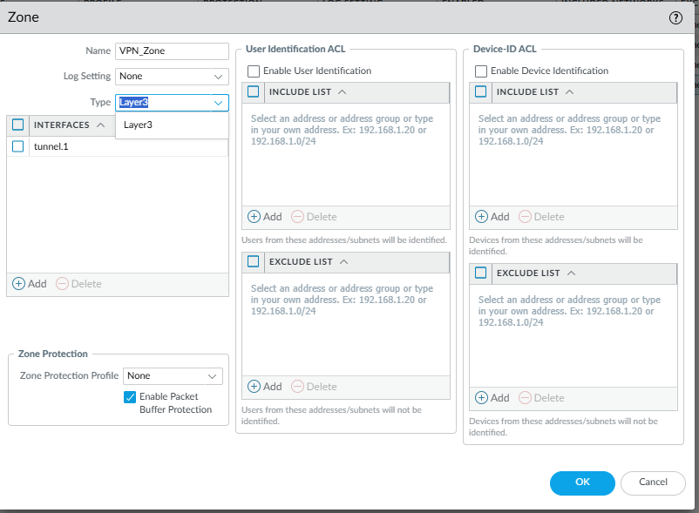

A) Create tunnel interfaces

SG: Network > Interfaces > Tunnel > ADD

tunnel.1, assign to VPN_Zone, and VR_SG set IP 10.10.10.1/30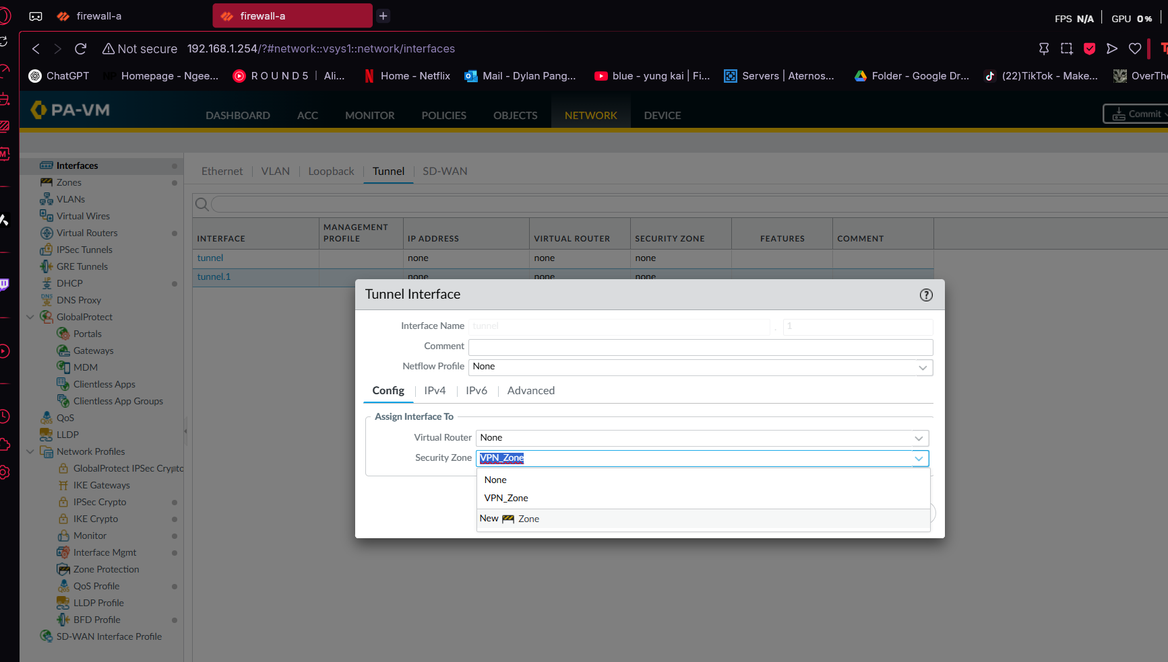

KL: Same steps, assign IP 10.10.10.2/30, and VR_KL

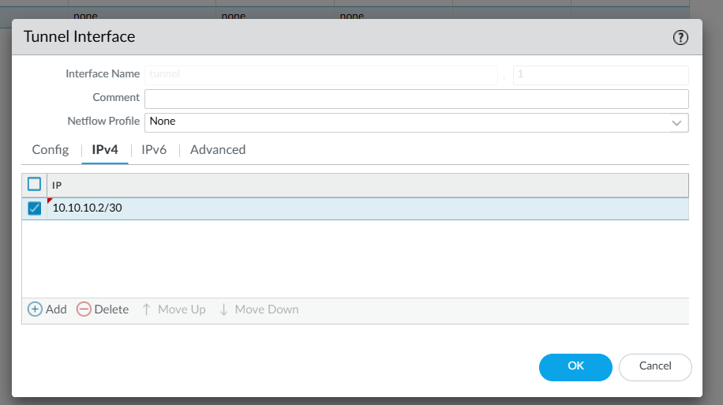Once done, Commit.

STEP 3: Create IKE Crypto Profile(Go to: Network > Network Profiles > IKE Crypto > Add)

Do for both SG and KL

Name: IKE-NSASG

Encryption: AES-256

Authentication: SHA-256

DH Group: Group 14

Lifetime: 28800s

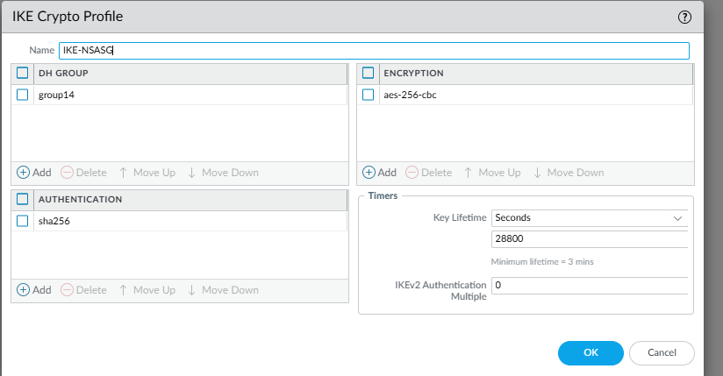

STEP 4: Create IKE Gateway (Go to: Network > Network Profiles > IKE Gateways > Add)

On SG:

Name: IKE-to-KL

Interface: ethernet1/1

Local IP: 192.168.8.9

Peer IP: 192.168.8.10

IKE Version: IKEv2 only

Pre-shared Key: nsasgvpn

Crypto Profile: IKE-NSASG

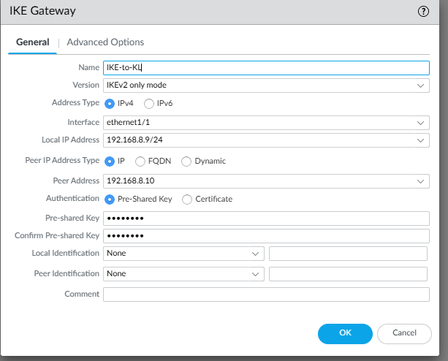

On KL:

Name: IKE-to-SG

Interface: ethernet1/1

Local IP: 192.168.8.10

Peer IP: 192.168.8.9

Use same key and profile

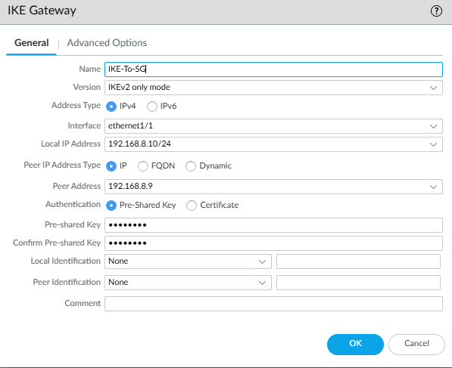

Click OK then Commit.

STEP 5: Create IPsec Crypto Profile (Go to: Network > Network Profiles > IPSec Crypto > Add)

Do for both SG and KL

Name: IPSec-NSASG

Encryption: AES-256

Authentication: SHA-256

DH Group: Group 14

Lifetime: 3600

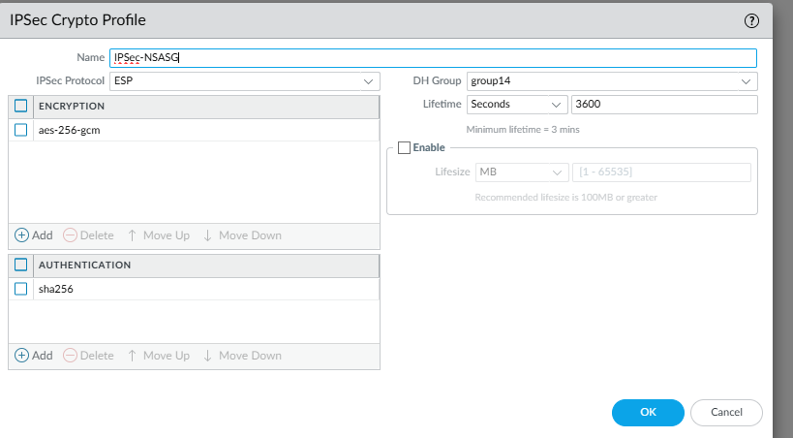

STEP 6: Create IPsec Tunnel

(Go to: Network > IPsec Tunnels > Add)

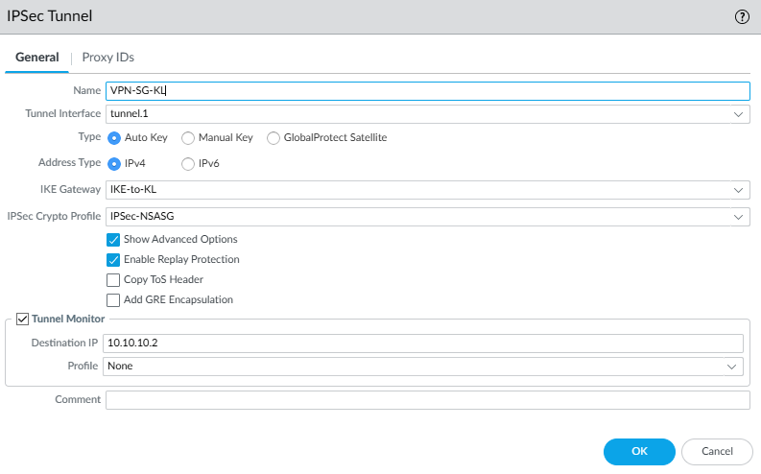

Name: VPN-SG-KL

Tunnel Interface: tunnel.1

IKE Gateway:

SG: select IKE-to-KL

KL: select IKE-to-SG

IPSec Crypto Profile: IPSec-NSASG

Enable Tunnel Monitoring:

SG: Destination IP = 10.10.10.2

KL: Destination IP = 10.10.10.1

Profile: default/none

Click OK then Commit

STEP 7: Add Static Routes (Go to: Network > Virtual Routers > VR_SG / VR_KL > Static Routes > Add)

On SG:

Name: to-KL

Destination: 192.168.30.0/24

Interface: tunnel.1

Next Hop: None

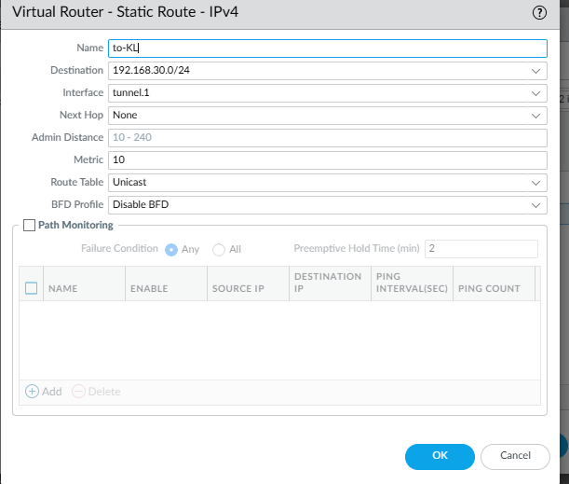

On KL:

Name: to-SG-HR

Destination: 192.168.10.0/24

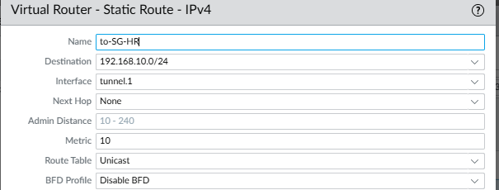

Name: to-SG-IT

Destination: 192.168.20.0/24

Interface: tunnel.1

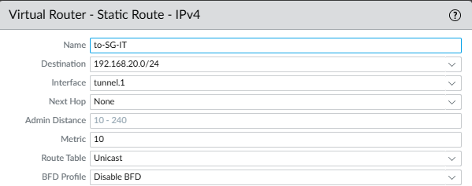

Once done, Click OK then Commit

STEP 8: Create Security Policies

(Go to: Policies > Security > Add)

On SG:

Name: SG_to_KL

Source Zone: HR_Zone, IT_Zone

Destination Zone: VPN_Zone

Destination Address: 192.168.30.0/24

Action: allow

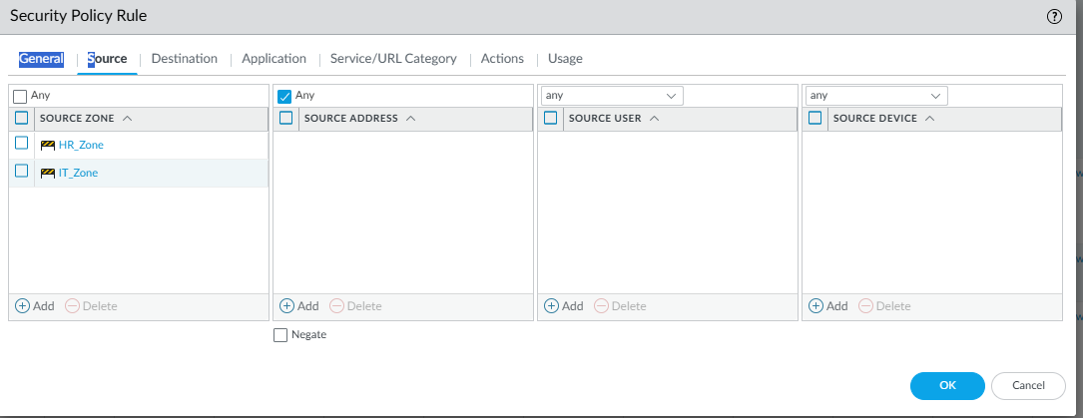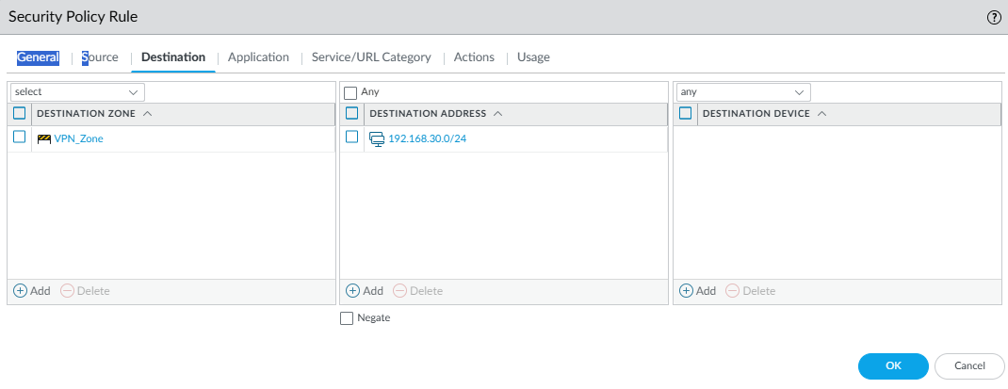

On KL:

Name: KL_to_SG

Source Zone: Sales_Zone

Destination Zone: VPN_Zone

Destination Address: 192.168.10.0/24, 192.168.20.0/24

Action: allow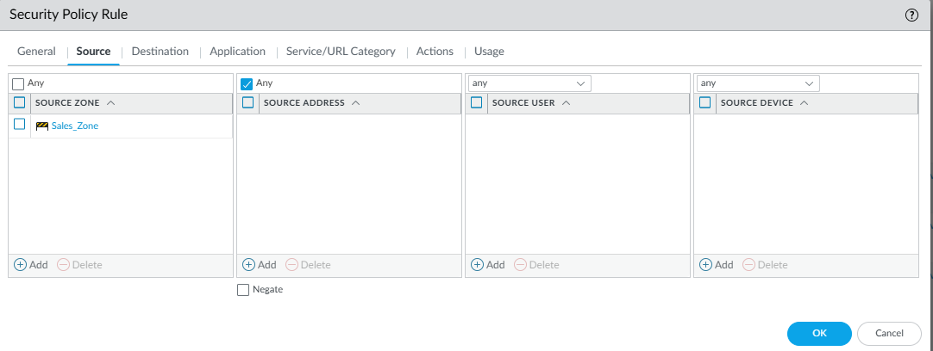

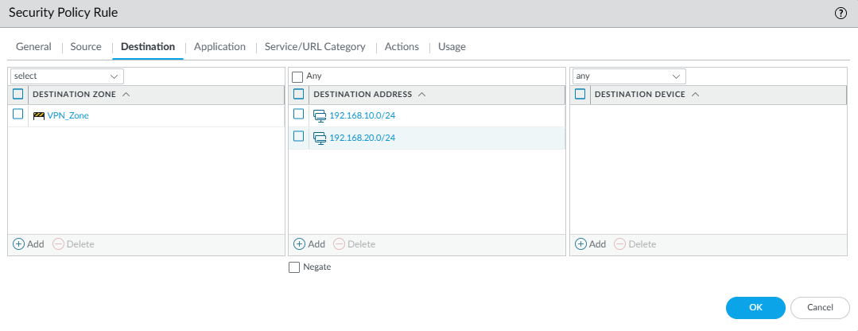

Once completed, Click OK then Commit.

STEP 9: Add NAT Bypass (No-NAT for VPN)

(Go to: Policies > NAT > Add)

On SG: Name: No-NAT-to-KL

Source Zone: HR_Zone, IT_Zone

Destination Zone: VPN_Zone

Destination Address: 192.168.30.0/24

Source Translation: None

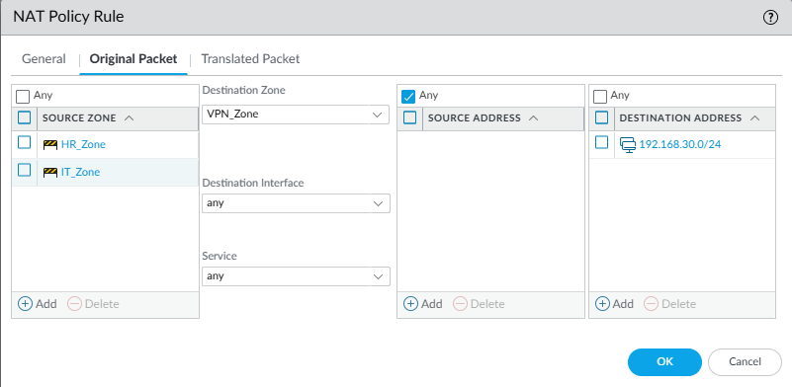

On KL: Name: No-NAT-to-SG

Source Zone: Sales_Zone

Destination Zone: VPN_Zone

Destination Address: 192.168.10.0/24, 192.168.20.0/24

Source Translation: None

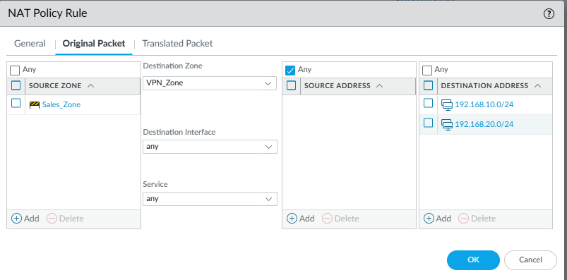

Place these above internet-NAT rules

SG:

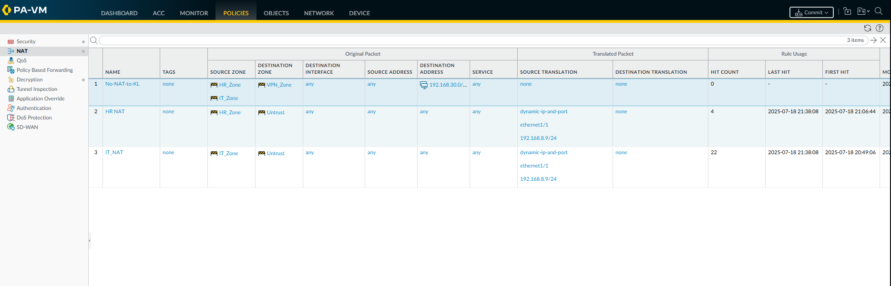

KL:

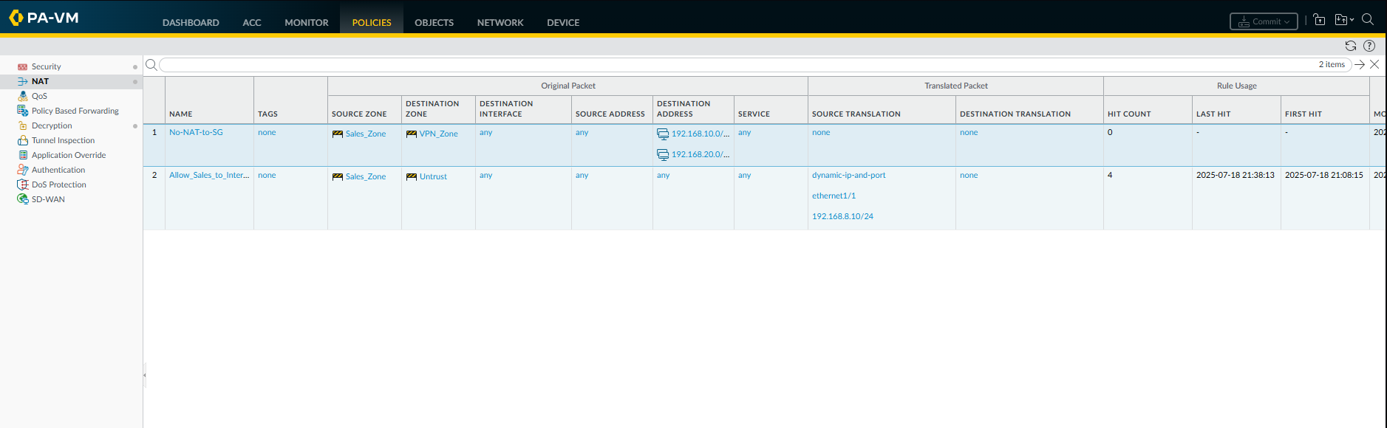

Once completed, commit.

STEP 10: Test Your VPN

Check Tunnel Status with:

Go to Network > IPsec Tunnels → Status should show green/UP



Test Traffic with:

SG PC: ping 192.168.30.10 (KL Sales)

KL PC: ping 192.168.10.10 or 192.168.20.10 (SG HR/IT)

## 11. IDS/IPS

### Antivirus

To configure the firewall to block malware (e.g., EICAR test file), monitor threat logs, and apply the correct security profiles to security policies.

### Singapore and KL Office

Step 1: Confirm Antivirus and Threat Profile Settings

1. Go to Objects > Security Profiles > Antivirus.
2. Ensure:
   1. HTTP, FTP, SMTP, IMAP actions are set to block.
3. Also review and configure:
   1. Anti-Spyware
   2. Vulnerability Protection
   3. URL Filtering

Step 2: Create or Verify Security Profile Group

1. Go to Objects > Security Profile Groups.
2. Create a group (e.g., sg-sp) and add the following:
   1. sg-av (Antivirus)
   2. sg-as (Anti-Spyware)
   3. sg-vp (Vulnerability Protection)
   4. sg-url (URL Filtering)

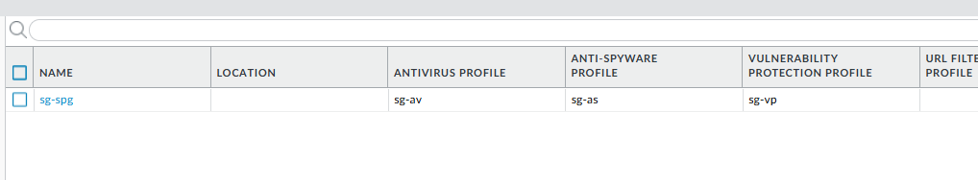

Step 3: Create Custom Vulnerability Profile

1. Go to Objects > Security Profiles > Vulnerability Protection.
2. Locate your custom profile named (e.g., sg-vp)
3. Confirm it has the following rule:
   1. Rule Name: (e.g., lab-vp-rule)
   2. Severity: high
   3. Action: reset-both
   4. Packet Capture: single-packet

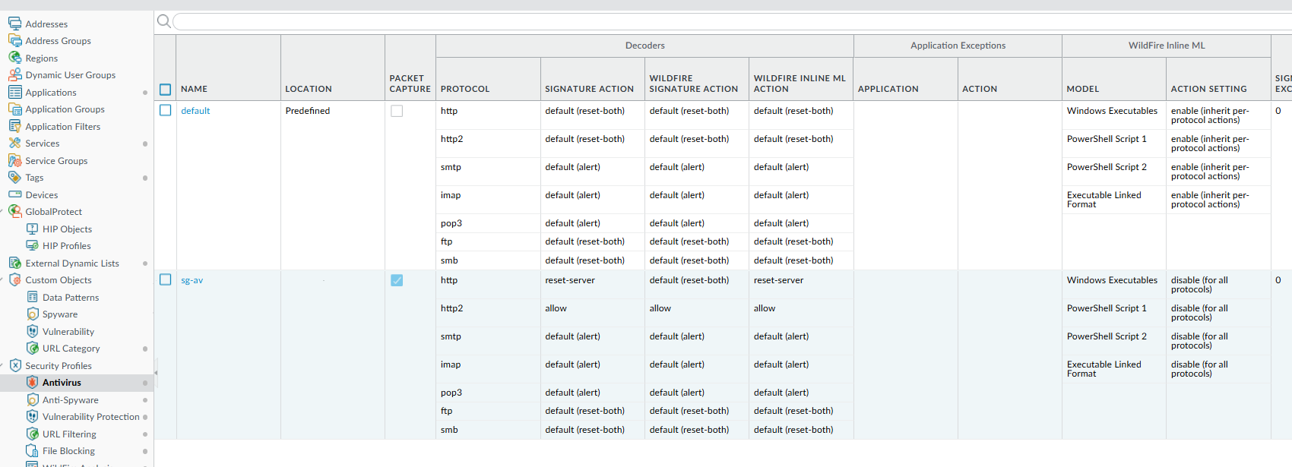

Step 4: Apply Security Profiles to Security Policies

1. Go to Policies > Security.
2. Edit each allow rule (e.g., Allow_Standard_Apps, Allow_Web_Traffic_HRIT).
3. Under the Actions tab:
   1. Set Profile Type: Profiles
   2. Attach the Security Profile Group: (e.g., sg-sp)

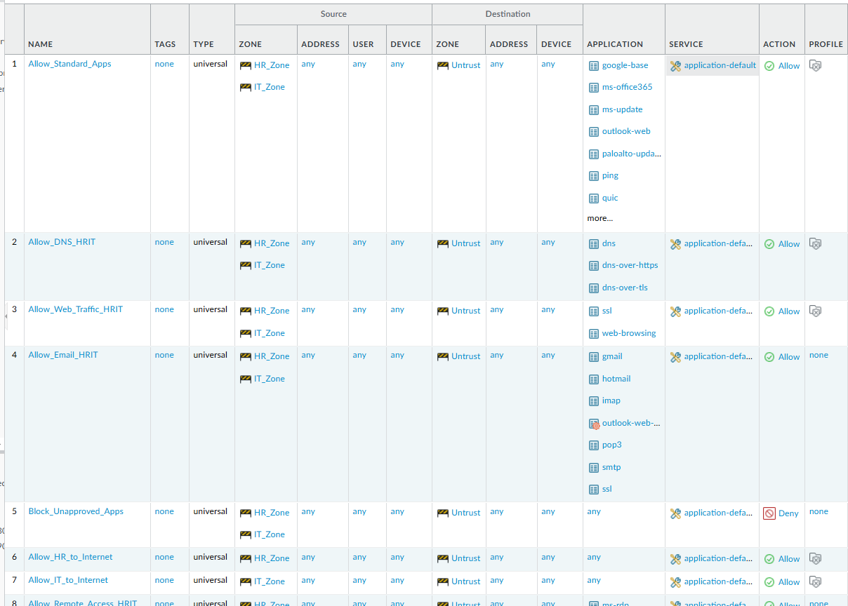

### File Blocking

#### Singapore Office

A file blocking profile named sg-fileblock was created in the firewall with the settings to block any .exe downloads, the profile was then attached to the same security profile group as per the Antivirus group, then attached onto the outbound internet security policy.

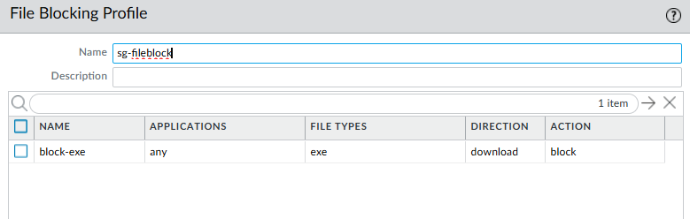

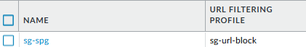

Effectiveness of policy can be seen in the testing portion of the report down below

#### KL Office

A similar file blocking profile named kl-fileblock was created on the KL firewall, but blocks mp4 downloads instead. This profile was attached to the same security profile group as the Antivirus group and then applied to the outbound internet security policy.

To verify the policy’s effectiveness, multiple .mp4 downloads were attempted from the KL Sales VM. All attempts were correctly identified by the firewall, and the files appeared in the client’s Downloads folder as 0KB. These files were non-functional and could not be executed. The firewall logs confirmed that all download attempts were detected and blocked as intended.

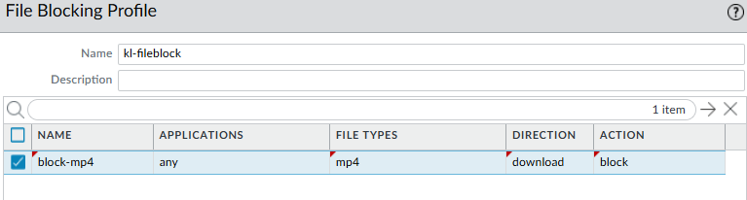

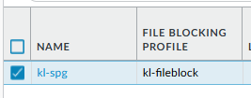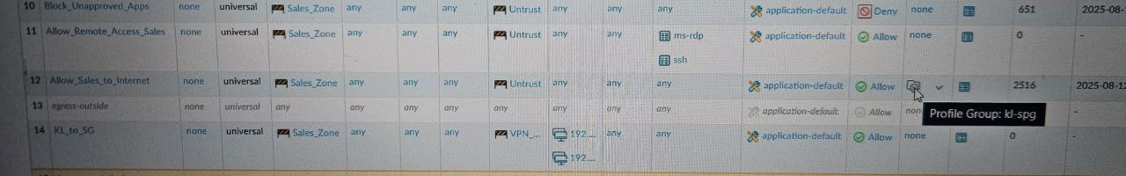

## 12. DOS Protection

Steps to configure:

Create a new DOS-Protection Profile

Objects → Security Profile → Dos Protection Profile → Add

Type: Classified

Flood Protection:

SYN Flood:

Alarm Rate: 50s

Activate Rate: 100s

Max Rate: 500s

Block Duration: 300s

UDP Flood

Alarm Rate: 50s

Activate Rate: 100s

Max Rate: 400s

Block Duration: 300s

ICMP Flood

Alarm Rate: 10s

Activate Rate: 30s

Max Rate: 40s

Block Duration: 60s

Other IP Flood

Alarm Rate: 100s

Activate Rate: 100s

Max Rate: 400s

Block Duration: 300s

Create a Dos Protection Policy:

Polices → DoS Protection → Add

Source:

VPN Zone

Destination:

HRZone and ITZone

Option/Protection

Action: Protect

Classified:

Profile: Internet Zone Protection

Address: source-ip-only

Repeat steps for Interzone connections within the SG firewall and the KL firewall

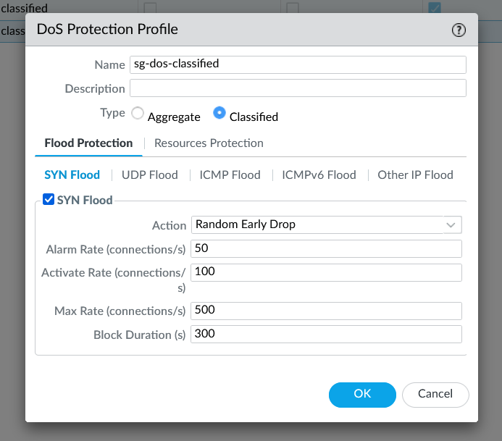

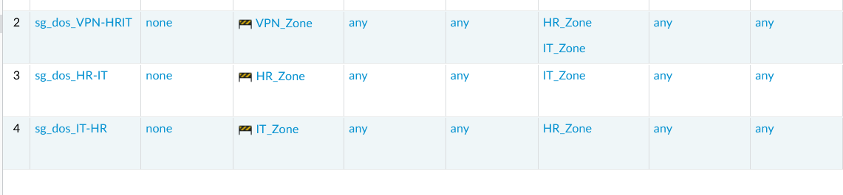**Configuring DOS protection rules for SG Firewall traffic**

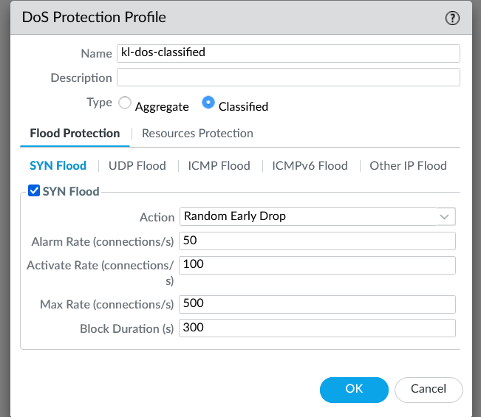**Configuring DOS protection rules for KL Firewall traffic**

# Testing & Results

## Network Traffic Policies for Departments

### SG HR Department (192.168.10.10)

#### Web Traffic

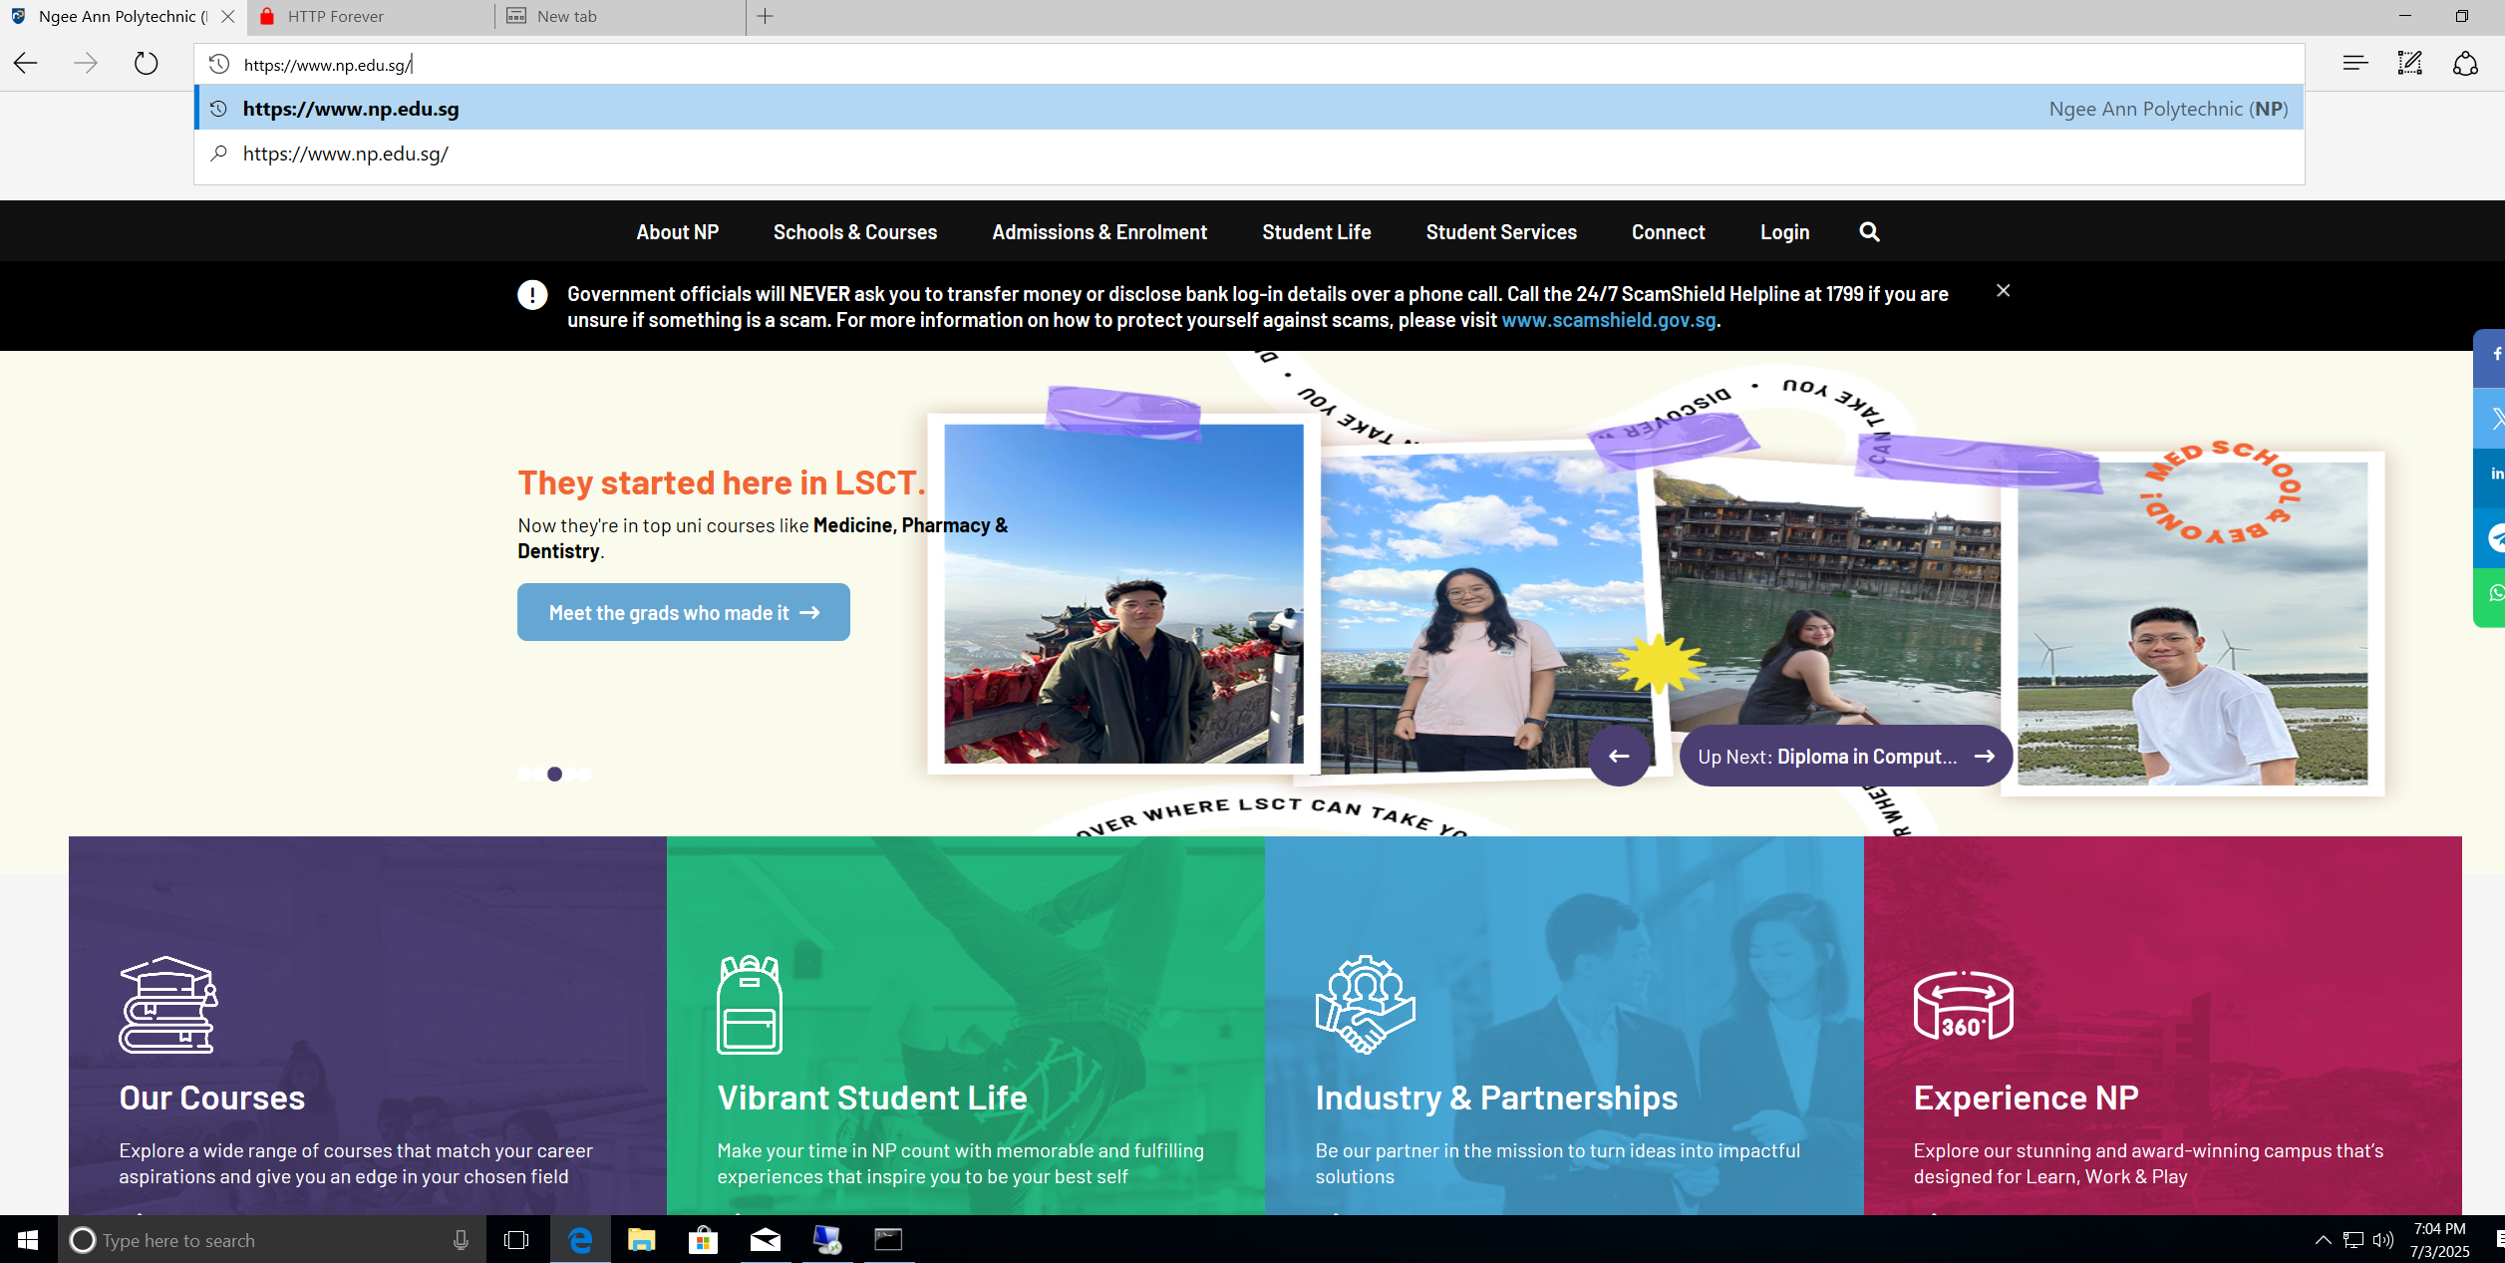

**Figure 1 : SG HR PC accessing a HTTPS site**

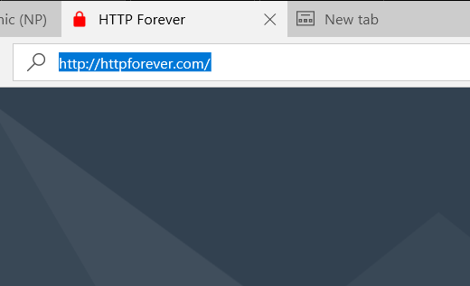

**Figure 2: SG HR PC accessing a HTTP site**

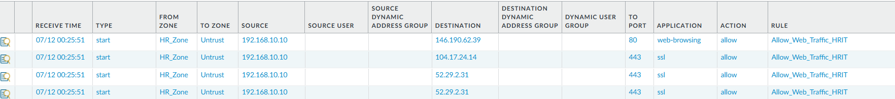

**Figure 3: Firewall logs HTTP and HTTPS traffic coming from SG HR’s PC**

#### DNS Traffic

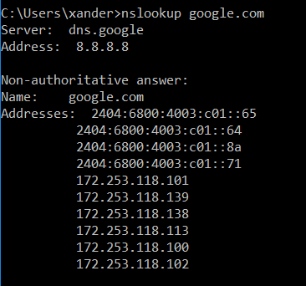

**Figure 4: Using nslookup in SG HR’s PC to check DNS resolution**



**Figure 5: Firewall logs DNS traffic coming from SG HR’s PC**

#### Email Traffic

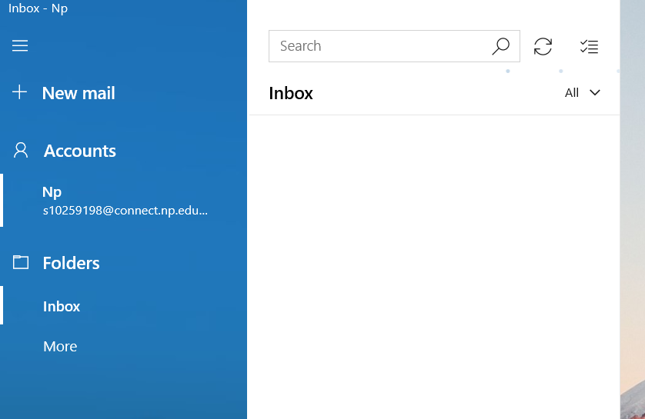

**Figure 6: Accessing email in SG HR’s PC**

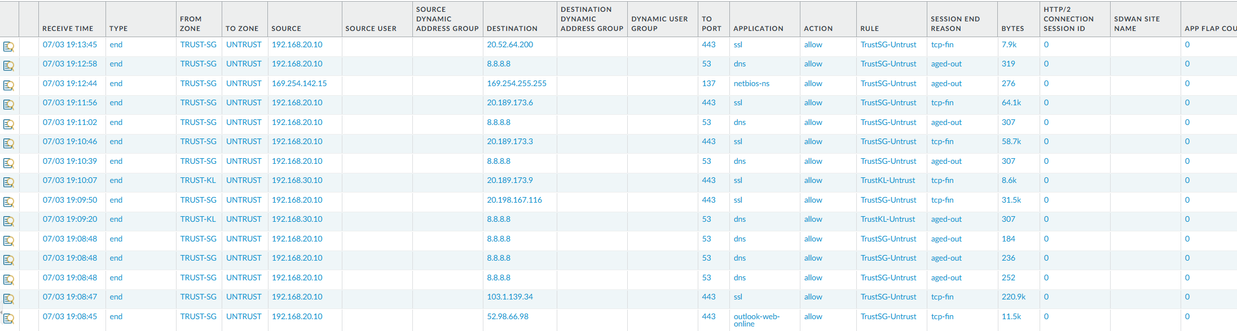

**Figure 7: Firewall logs Outlook-Web-Online traffic coming from SG HR’s PC**

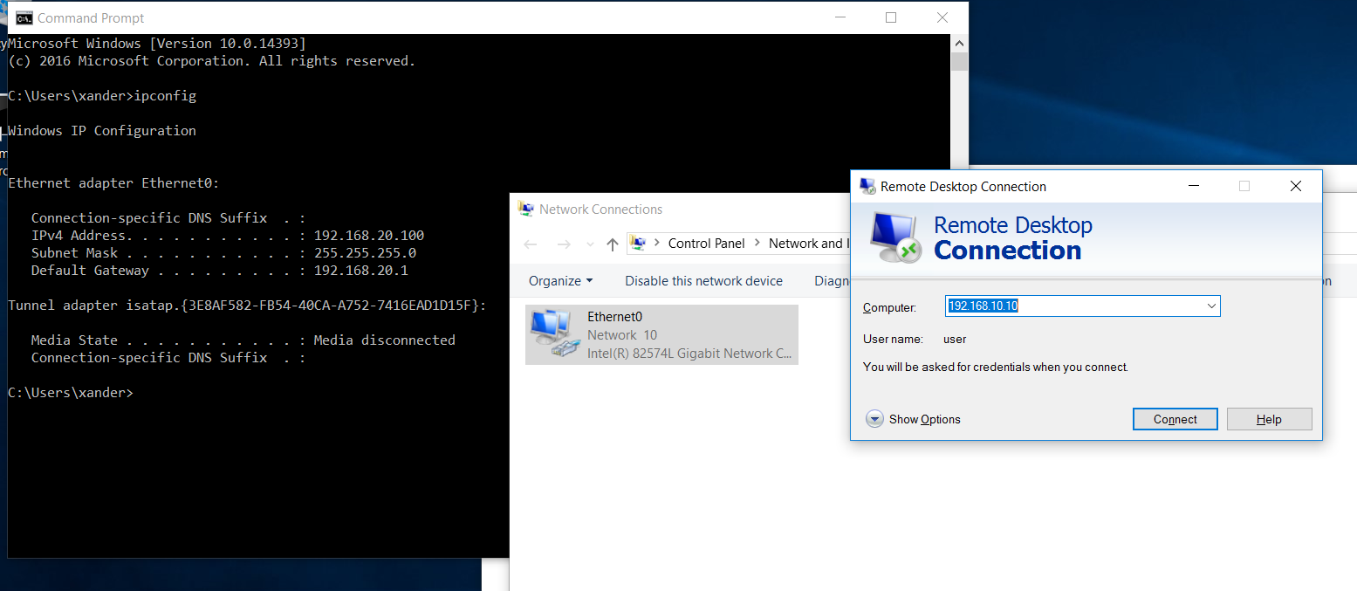

**Figure 13: Using a test PC in the same subnet as SG HR’s PC (192.168.10.100) to RDP into SG HR’s PC (192.168.10.10)**

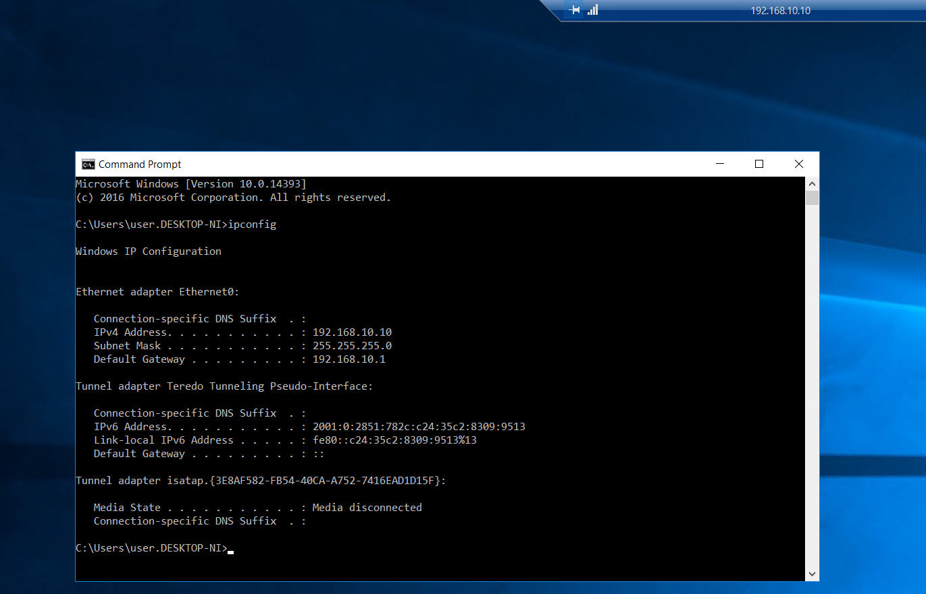

**Figure 14: Successful remote connection into SG HR’s PC Department (192.168.20.200)**

### SG IT Department (192.168.20.10)

#### Web Traffic

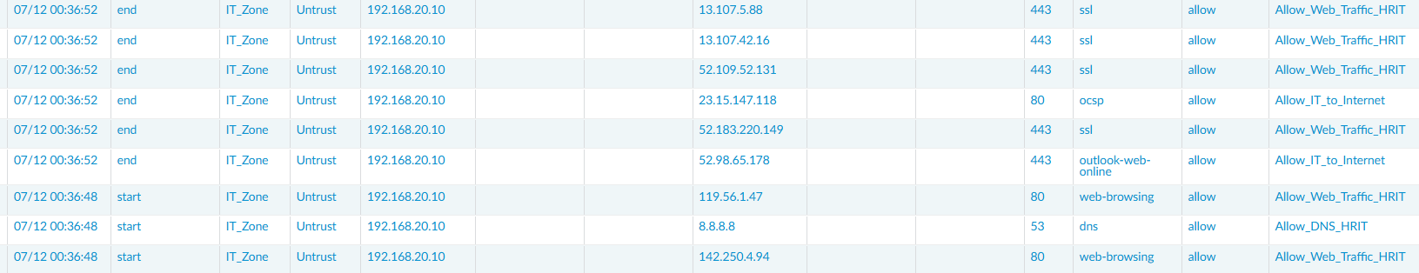

**Figure 10: Firewall logs HTTP and HTTPS traffic coming from SG IT’s PC**

#### DNS Traffic



**Figure 11: Firewall logs DNS traffic coming from SG IT’s PC**

#### Email Traffic



**Figure 12: Firewall logs Outlook traffic coming from SG IT’s PC**

#### Remote Access (RDP)

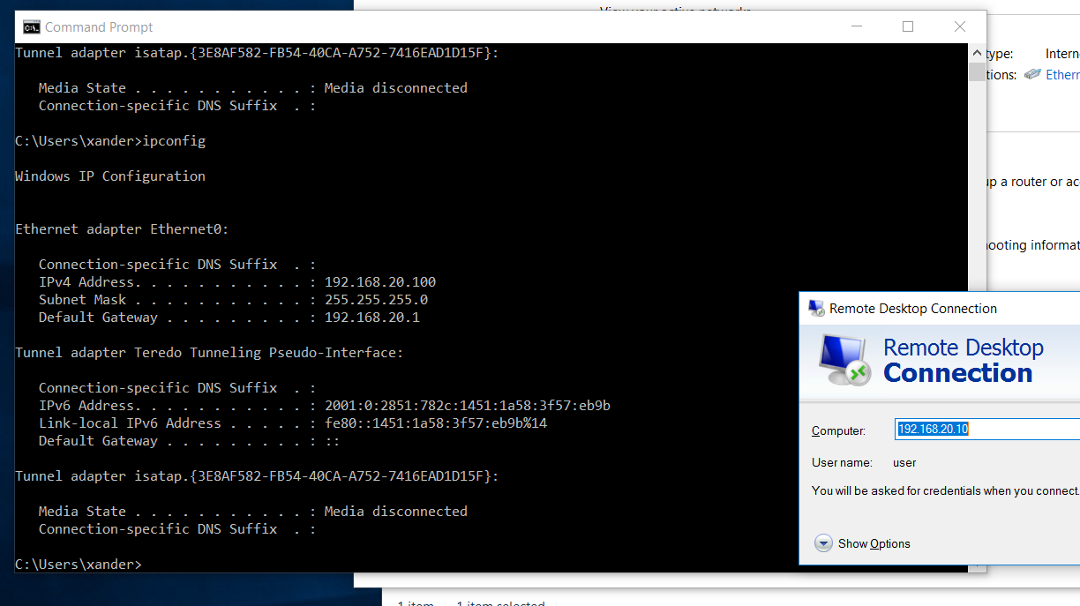

**Figure 13: Using a test PC in the same subnet as SG IT’s PC (192.168.20.100) to RDP into SG IT’s PC (192.168.20.10)**

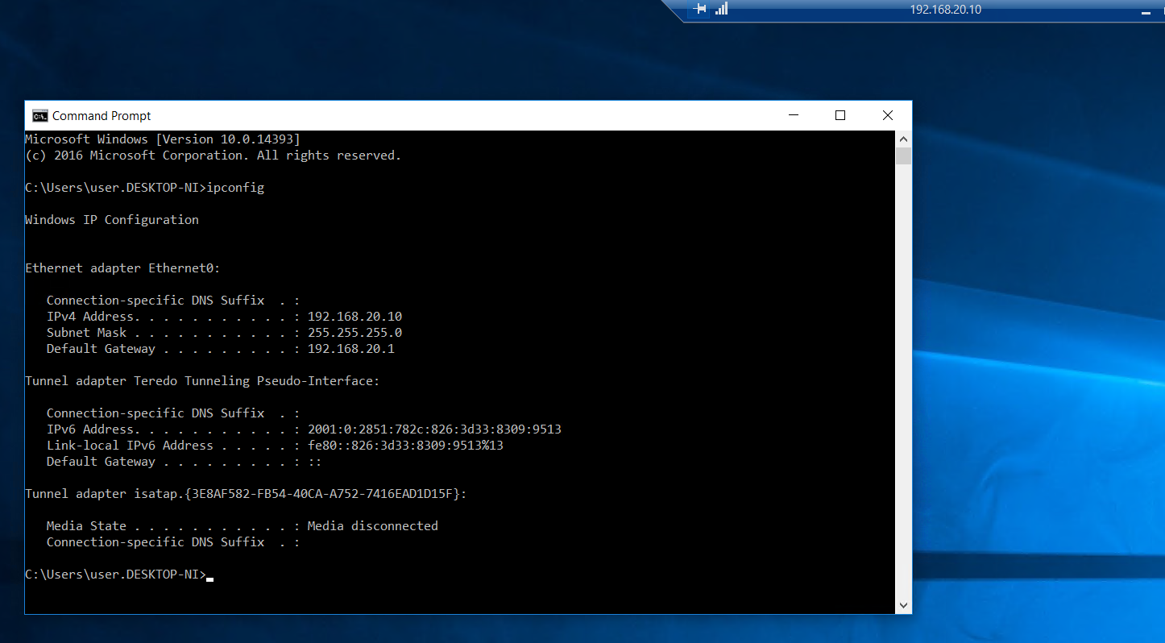

**Figure 14: Successful remote connection into SG IT’s PC**

### KL Sales Department (192.168.30.10)

Web Traffic

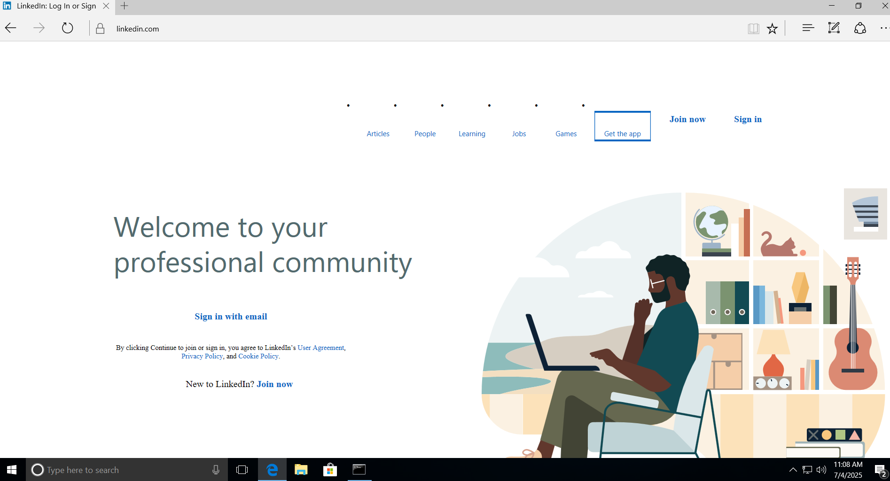

**Figure 15: KL Sales’s PC accessing a HTTPS site**

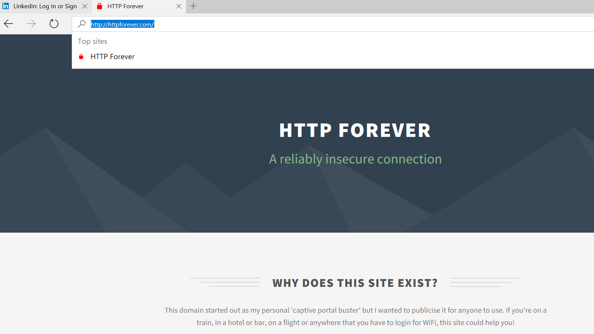

**Figure 15: KL Sales’s PC accessing a HTTP site**

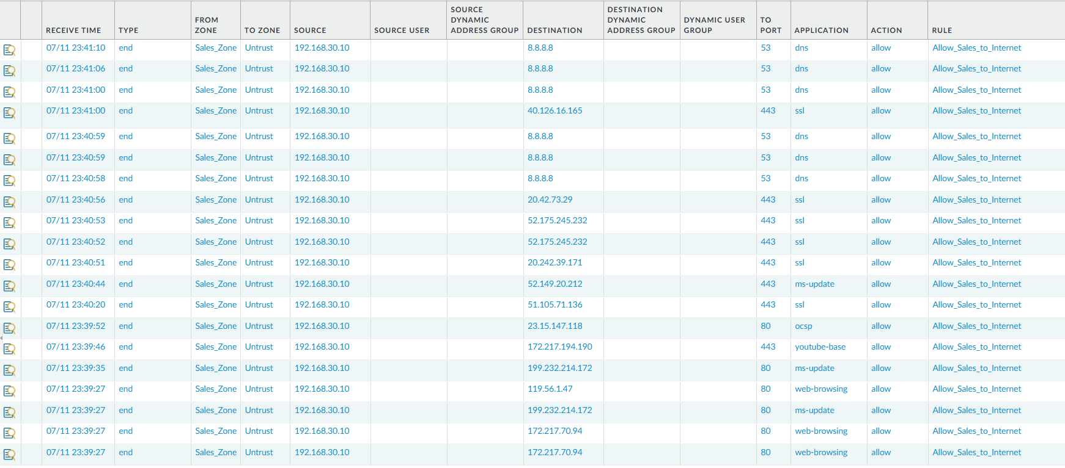

**Figure 16: Firewall logs HTTP and HTTPS traffic coming from KL Sale’s PC**

DNS Traffic

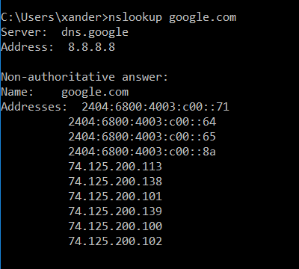

**Figure 17: Using nslookup in KL Sales’s PC to check DNS resolution**



**Figure 18: Firewall logs DNS traffic coming from KL Sales’s PC**

Email Traffic

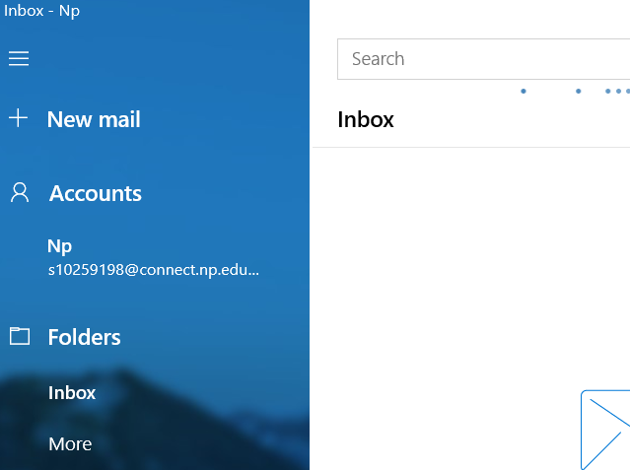

**Figure 19: Accessing email in KL Sales’s PC**



**Figure 20: Firewall logs Outlook-Web-Online traffic coming from KL Sales’s PC**

Remote Access (RDP)

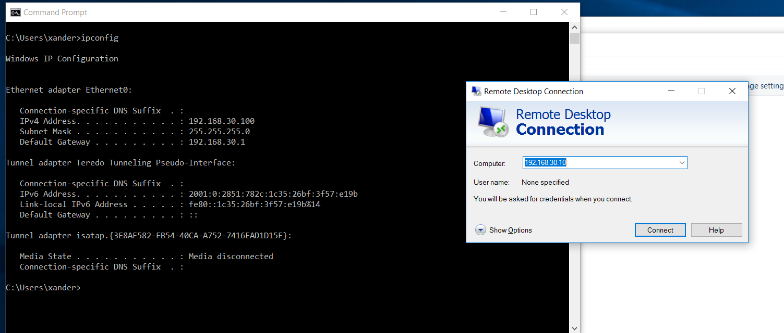

**Figure 21: Using a test PC in the same subnet as KL Sales’s PC (192.168.30.100) to RDP into KL Sales’s PC (192.168.30.10)**

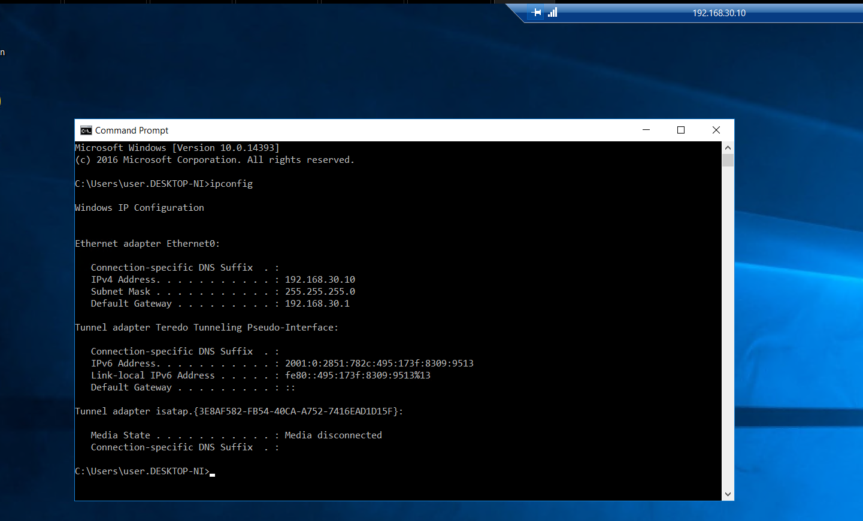

**Figure 22: Successful remote connection into KL Sales’s PC**

App-ID Implementation

SG Office

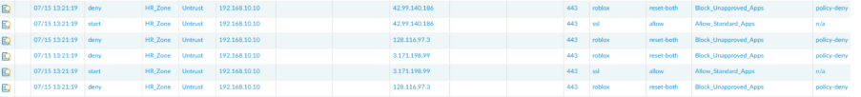

**Figure 1: Logs showing unsuccessful access to roblox**



**Figure 2: Log showing successful access to Microsoft office**

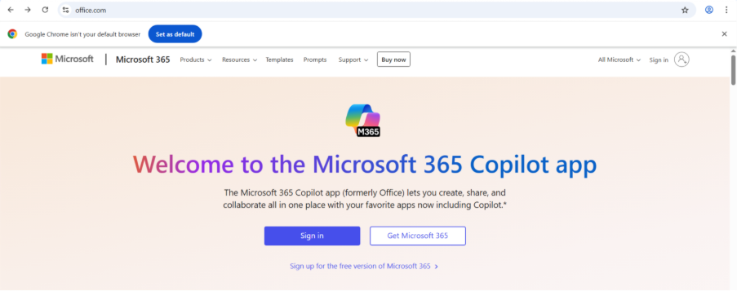

**Figure 3: Successful access to Microsoft office**

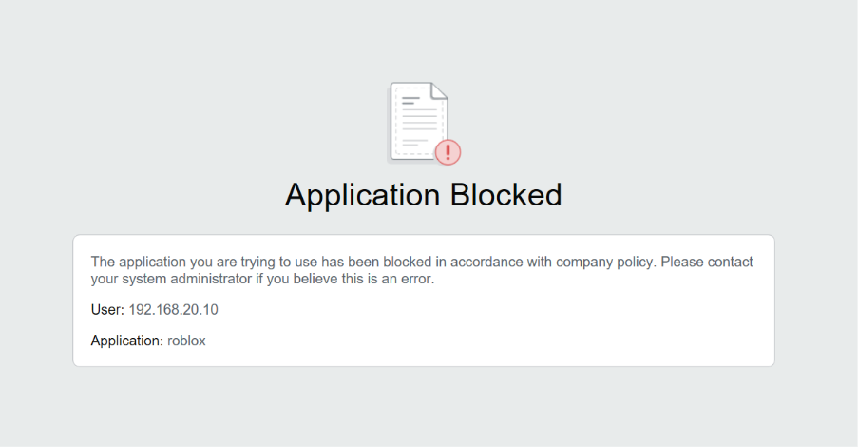  
 **Figure 4: Unsuccessful access to roblox from IT Zone**

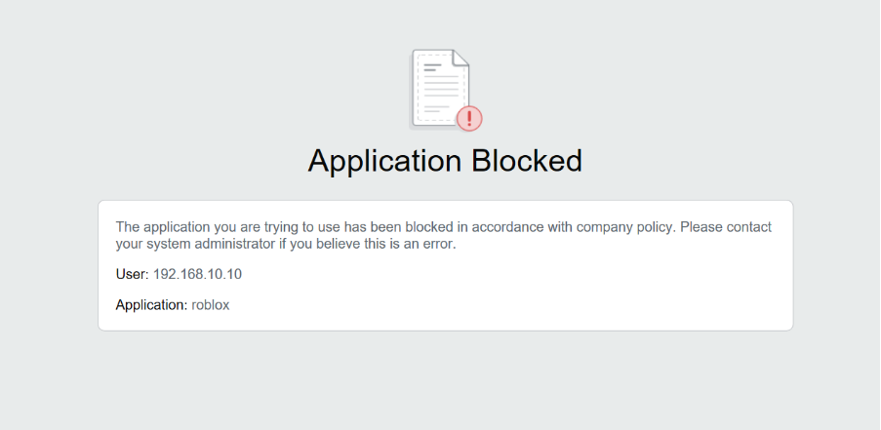  
 **Figure 5: Unsuccessful access to Roblox from HR Zone**

### KL Office

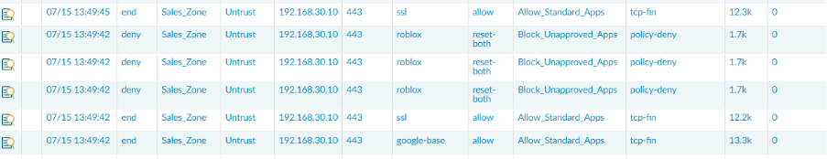  
 **Figure 6: Unsuccessful access to Roblox**

  
 **Figure 7: Successful access to Microsoft office**

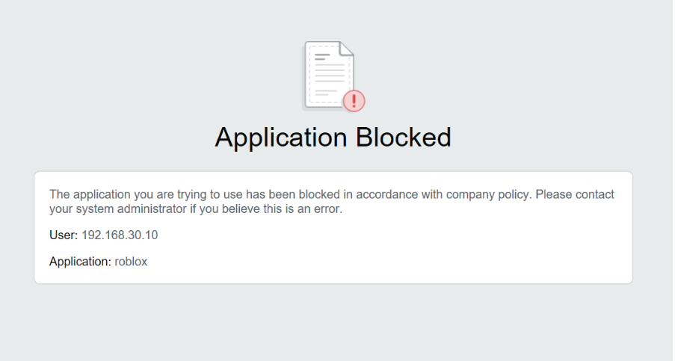  
 **Figure 8: Unsuccessful access to roblox from Sales Zone**

## Traffic Decryption Policies

### SG Office



**Figure 1: Uninspected SSL traffic due to nodecrypt_banking policy**

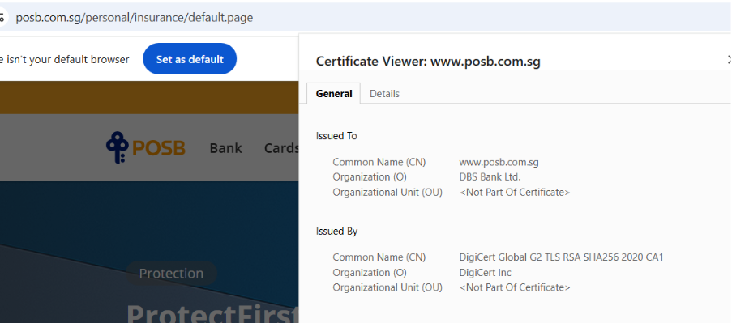

**Figure 2: POSB site showing external certificate – not decrypted**

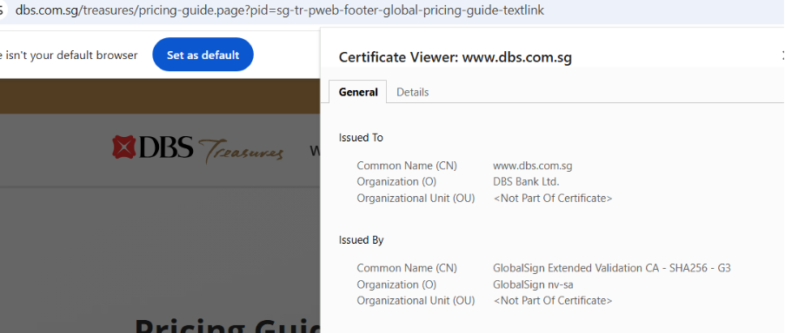

**Figure 3: DBS site showing external certificate – not decrypted**

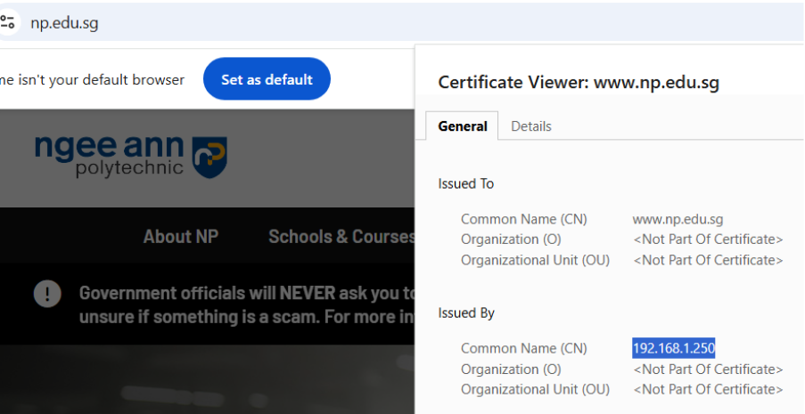

**Figure 4: np.edu.sg showing internal certificate – decrypted**

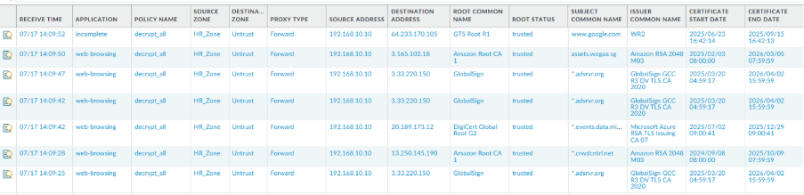

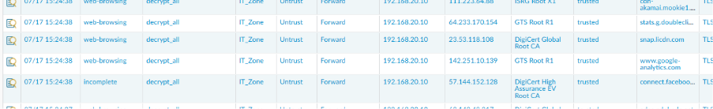 **Figure 5: Traffic logs showing decrypted sessions by decrypt_all policy**

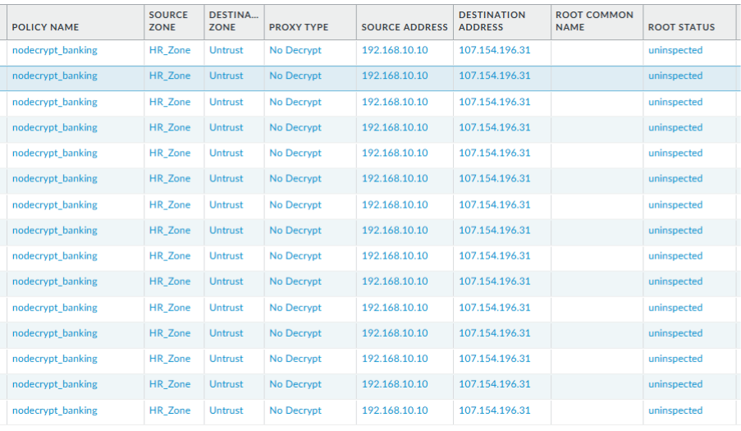  


**Figure 6: Undecrypted sessions by nodecrypt_banking policy**

### KL Office

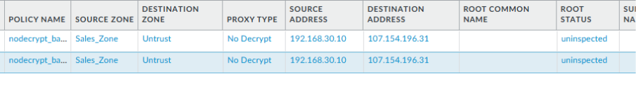

**Figure 7: Undecrypted sessions by nodecrypt_banking policy**

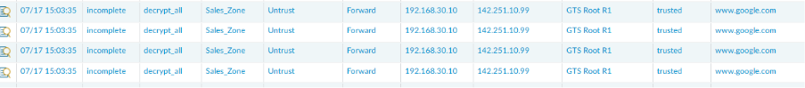

**Figure 8: Traffic logs showing decrypted sessions by decrypt_all policy**

## LinkedIn Access Control

Denying IT and Sales accessing Linkedin

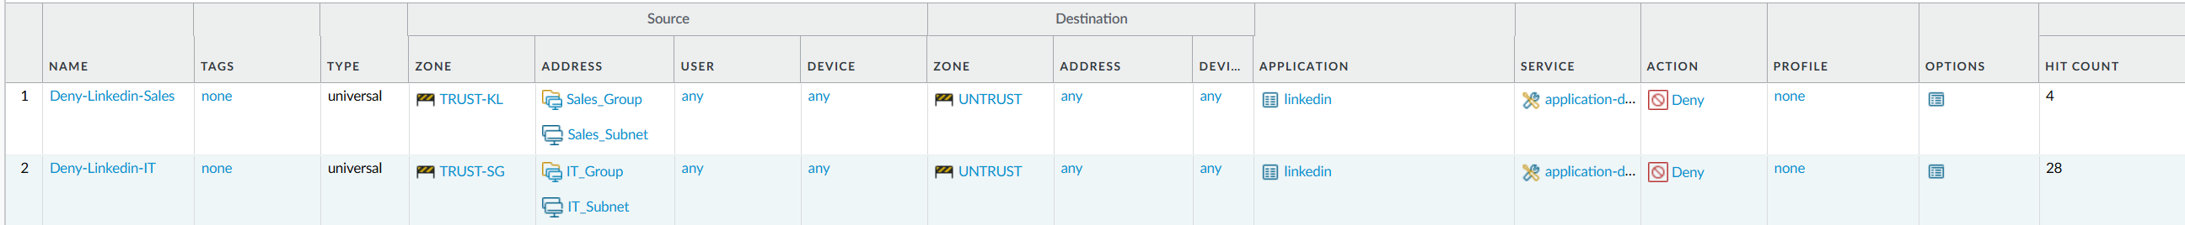

Allowing HR to access Linkedin but preventing messaging



Hr cannot message

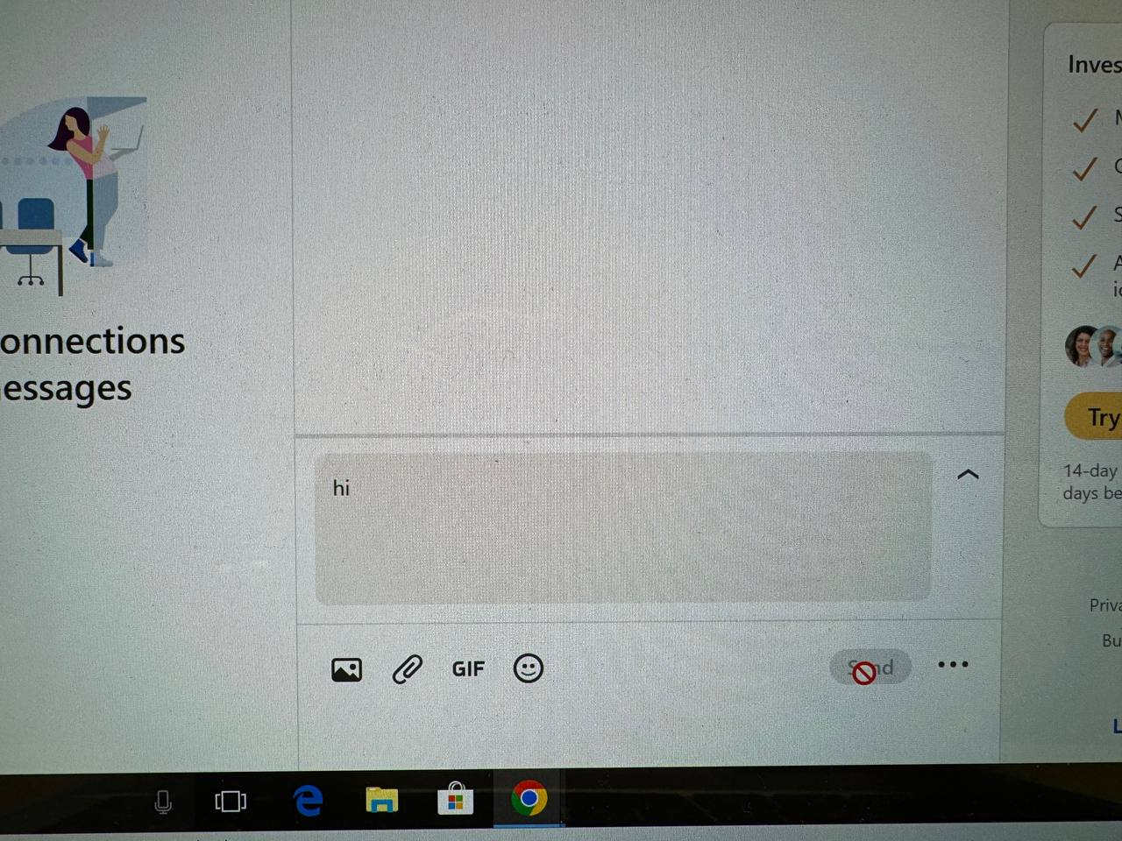

KL and Sales not being able to use Linkedin

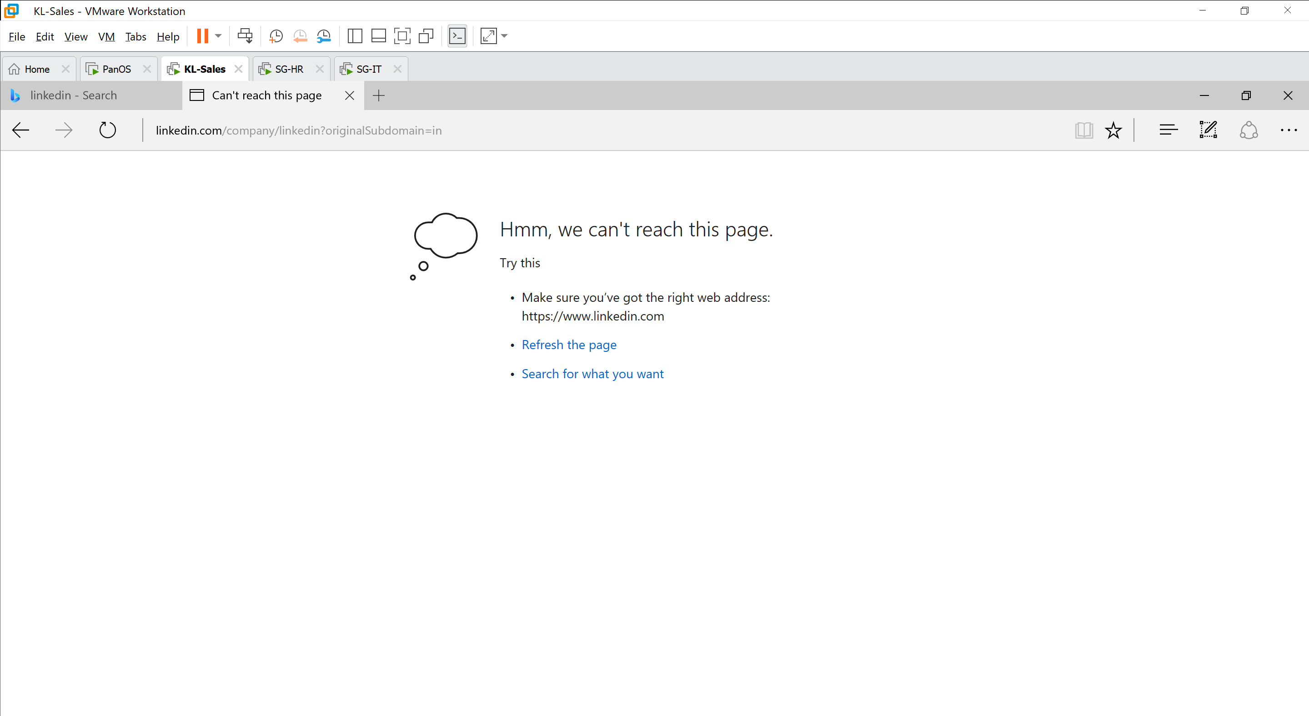



## Facebook Access Control

## Restriction on Online Storage Services

### SG Office

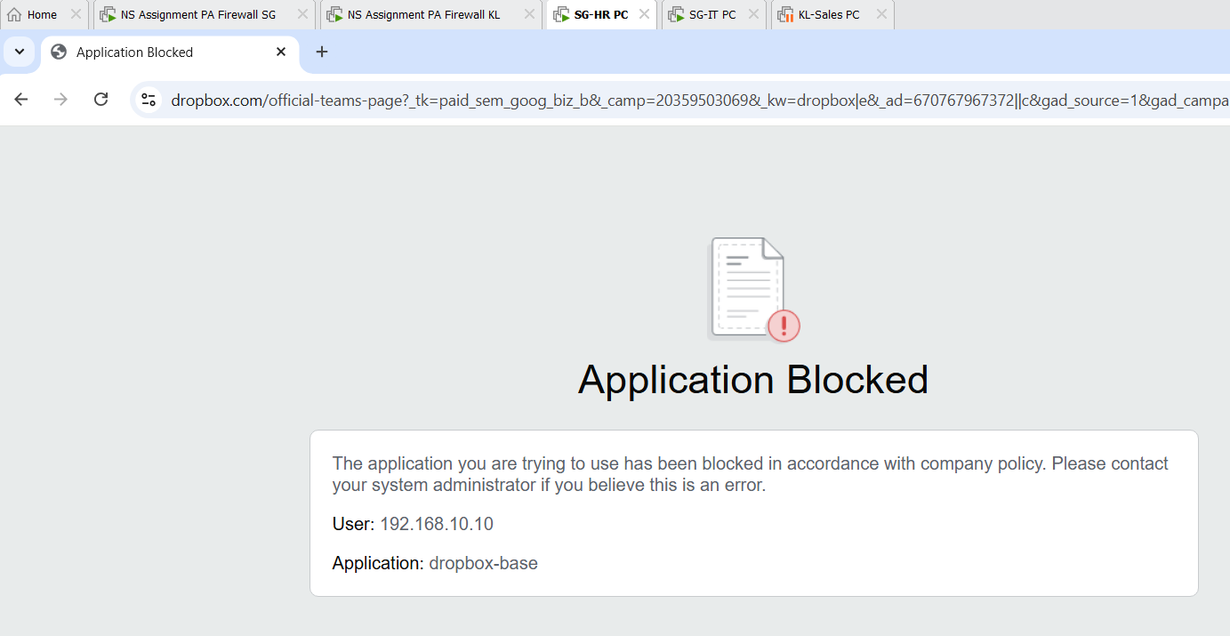

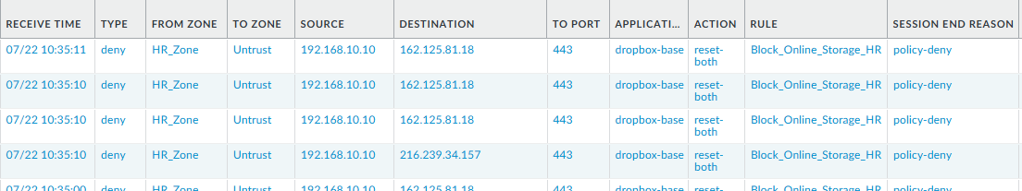

**Attempting to access an online storage service on the HR-SG computer**

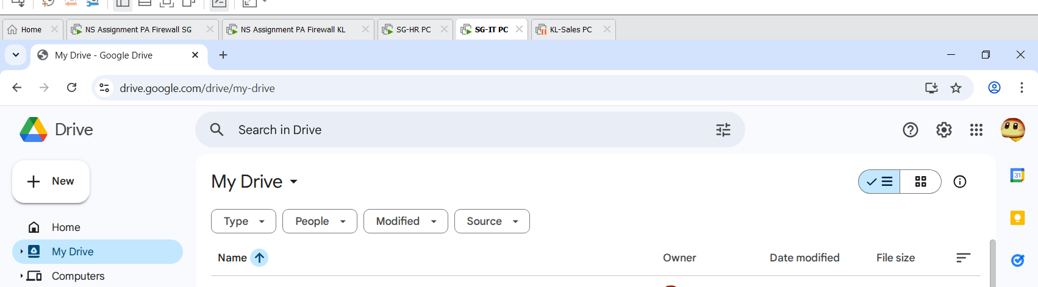

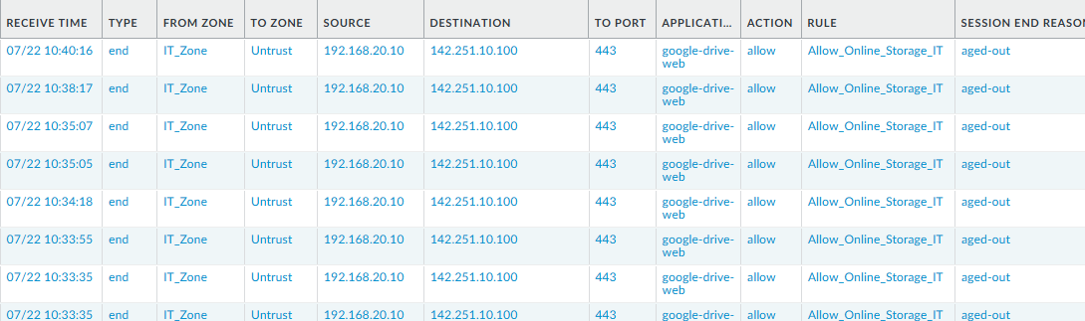**Successfully accessing Google Drive from the IT-SG computer**

### KL Office

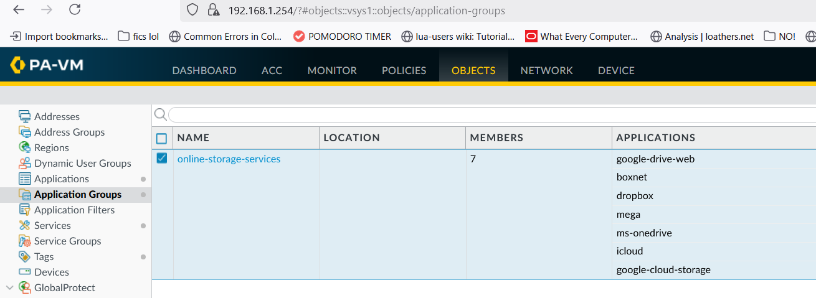

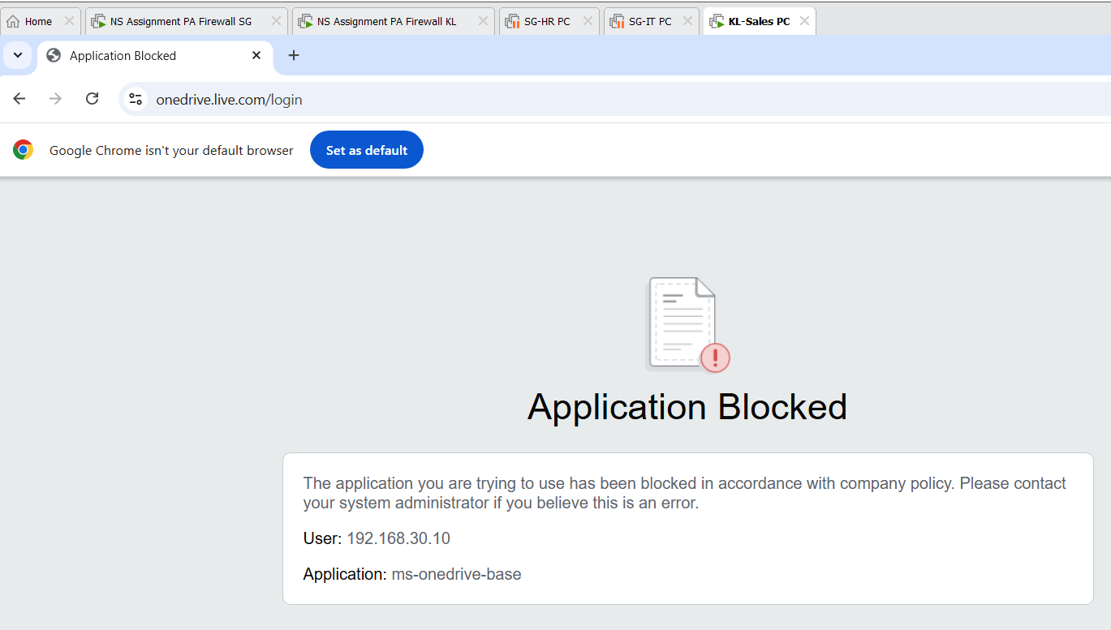

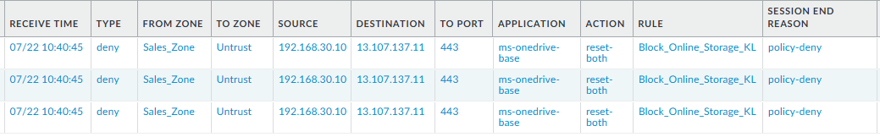**Attempting to visit an online storage service from the KL-Sales PC**

## VPN Connection

### SG Office

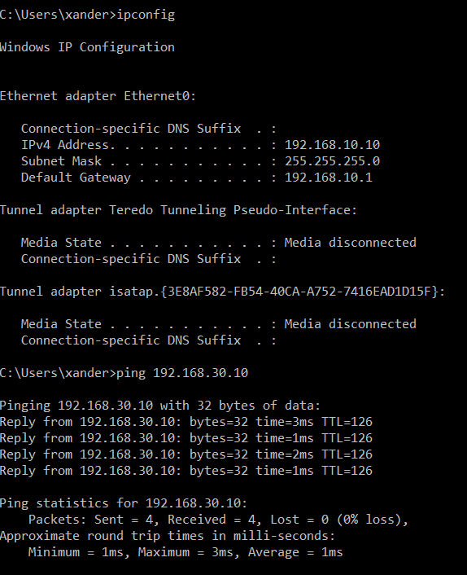

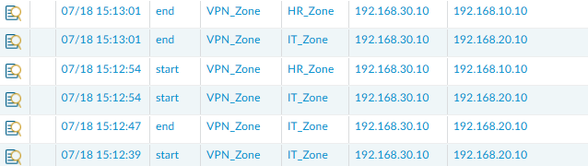

**SG HR (192.168.10.10) successfully pinging KL SALES (192.168.30.10)**

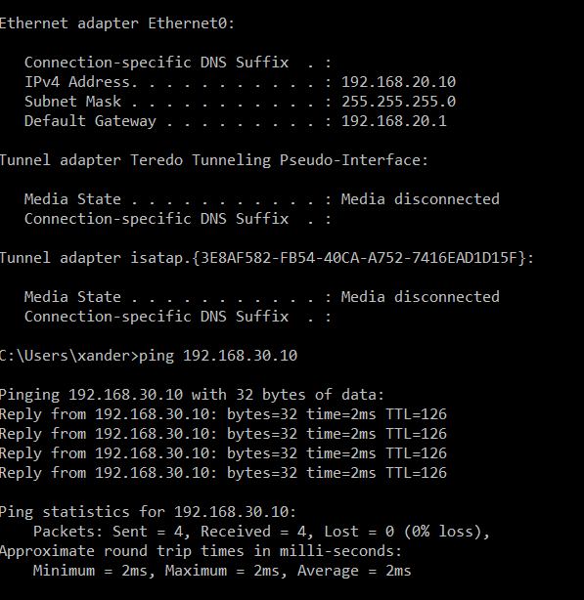

**SG IT (192.168.20.10) successfully pinging KL SALES (192.168.30.10)**

### KL Office

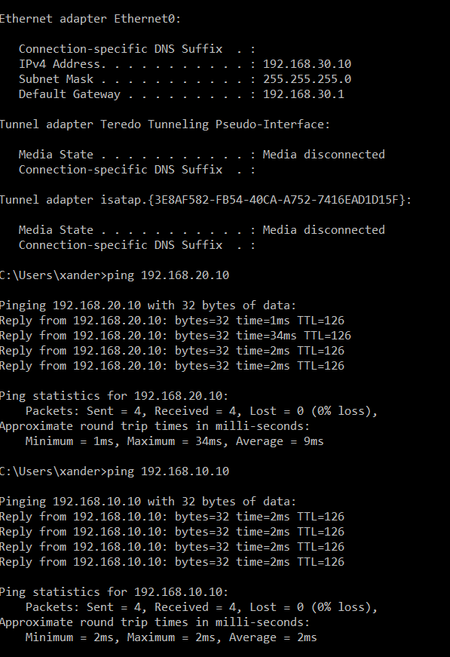

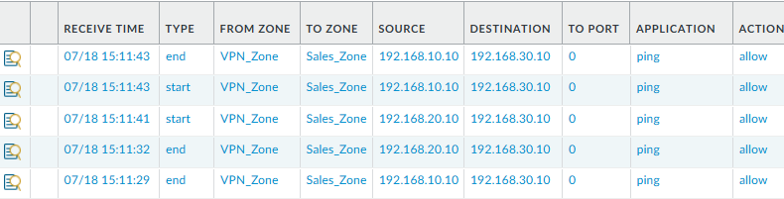

**KL SALES (192.168.30.10) successfully pinging SG HR AND IT (192.168.10.10, 192.168.20.10)**

IPS/IDS

SG Office

#### Antivirus

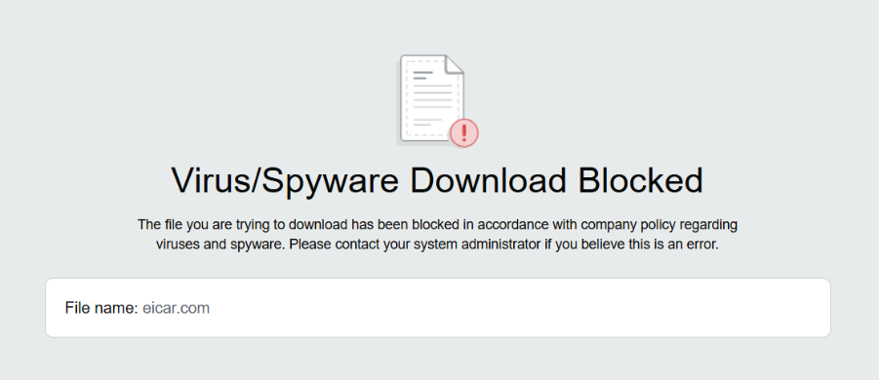

**Virus download blocked by antivirus profile**

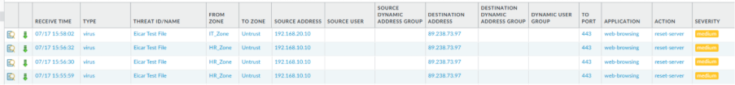

**Threat logs showing Eicar virus blocked by antivirus profile**

#### File Blocking

To verify the effectiveness of this file blocking policy, multiple executable file download attempts were performed from SG’s HR and IT PCs, these files include ChromeSetup.exe, SpotifySetup.exe, MSTeamsSetup.exe, ZoomInstallerFull.exe and Firefox Installer.exe.

All these downloads were identified by the firewall, they appeared in the client’s Downloads folder as 0KB, they were non-functional and cannot be executed. The firewall also correctly logged the attempts.

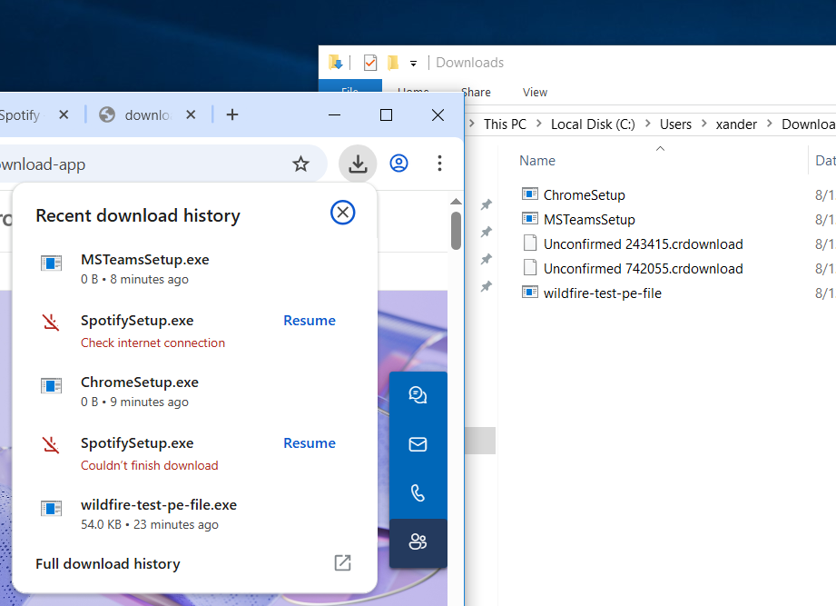

**EXE files failed to download on HR’s PC**

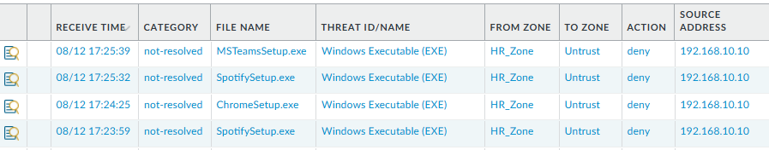

**Firewall logs HR’s PC attempts to download the exe files**

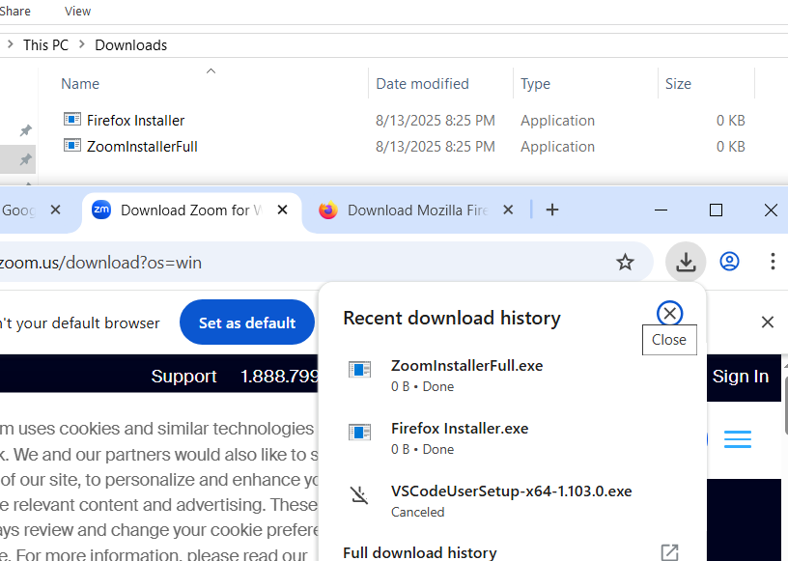

**EXE files failed to download on IT’s PC**

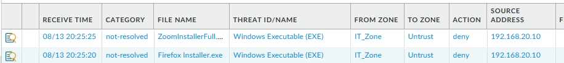

**Firewall logs IT’s PC attempts to download the exe files**

### KL Office

#### Antivirus



**Virus download blocked by antivirus profile**



**Threat logs showing Eicar virus blocked by antivirus profile**

#### File Blocking

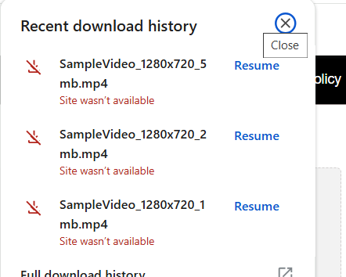

**mp4 files failed to download on Sale’s PC**

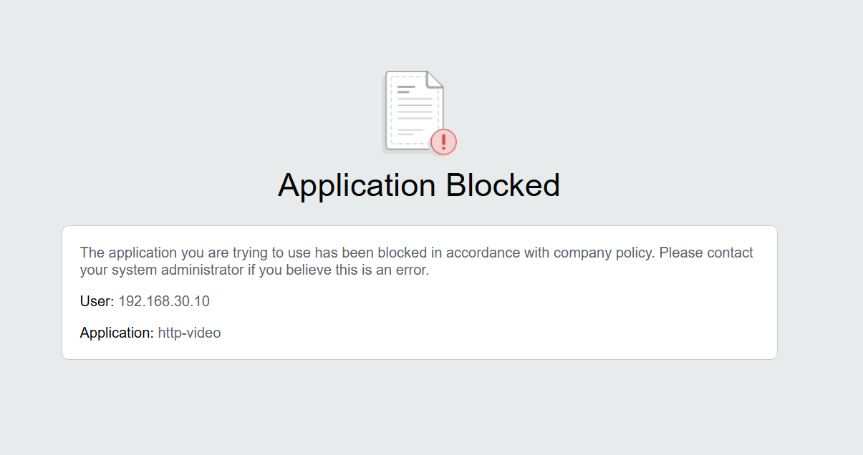

## DOS Protection

SG

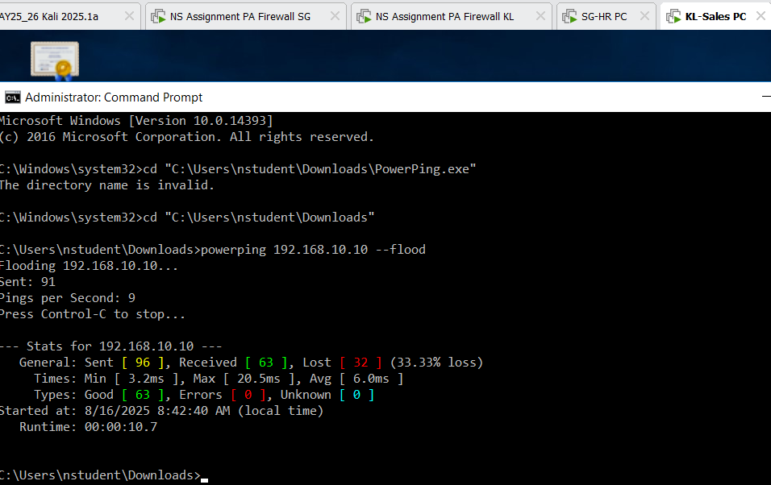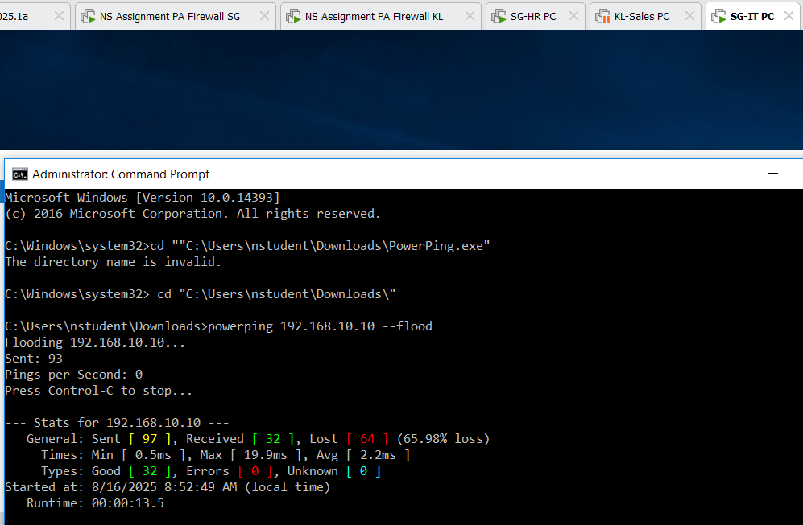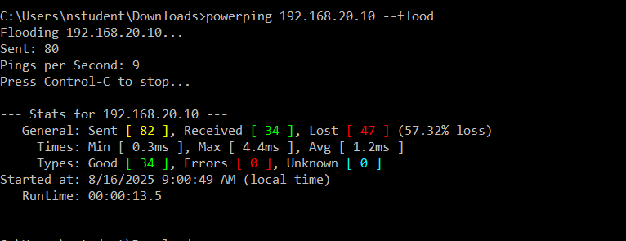

**Testing the DOS policy using PowerPing**

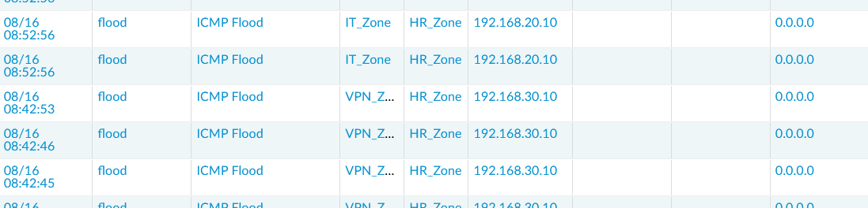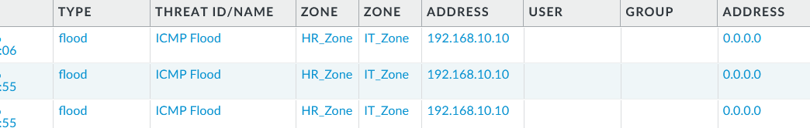**Logs of the DOS policy showing the Powerping flood**

KL

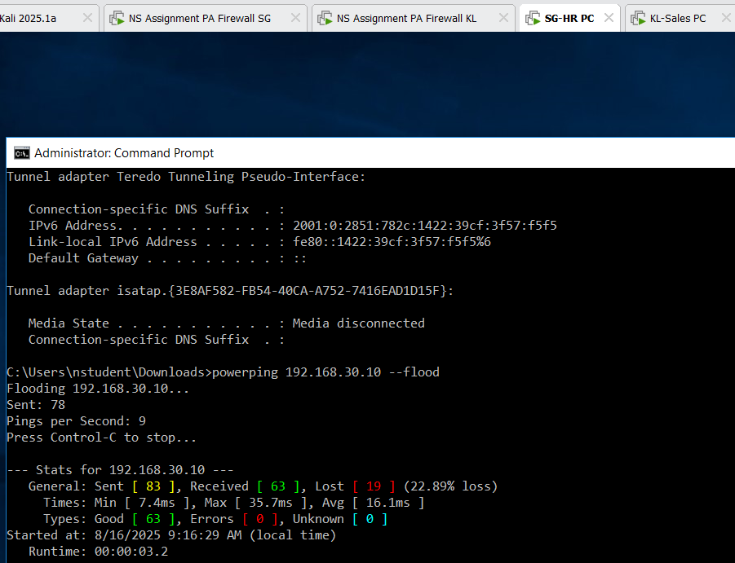**Testing the policy using Powerping**

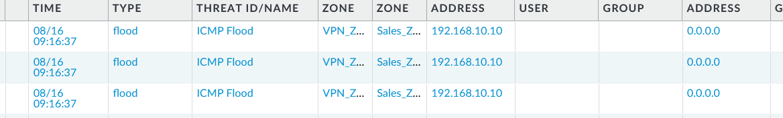**Logs of the DOS policy showing the Powerping flood**

# Geo-IP Blocking

To further reduce the attack surface of the organization, Geo-IP blocking was implemented on the firewalls at both the Singapore and Kuala Lumpur offices. This feature leverages the firewall’s internal geographic IP database to identify and deny network traffic originating from high-risk or non-business-related countries. It is especially effective against reconnaissance scans, brute-force login attempts, and malware command-and-control callbacks initiated from overseas threat actors. This feature is implemented without requiring any additional license.

Create a Security Policy to Block High-Risk Countries

Navigate to Policies > Security and click Add.

In the General tab, name the rule: Block_High_Risk_Countries.

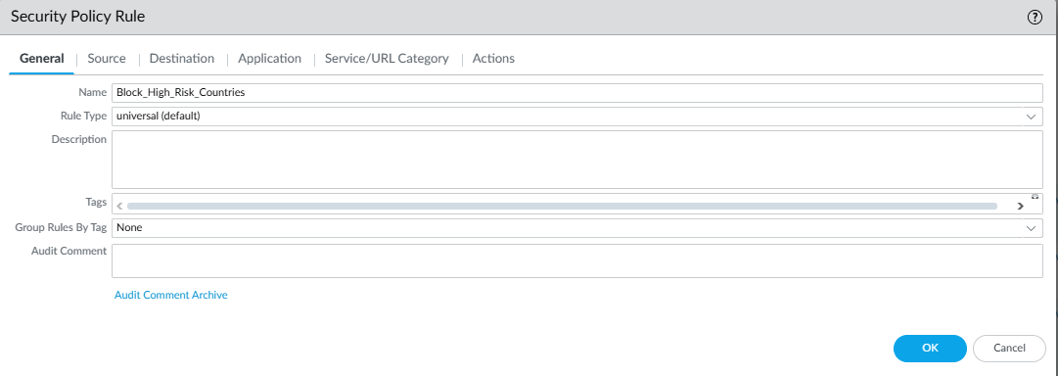

Source Tab:

Source Zone: Untrust

Source Address:

Choose the following regions (or others as appropriate):

* North Korea
* Russia
* Iran
* Israel

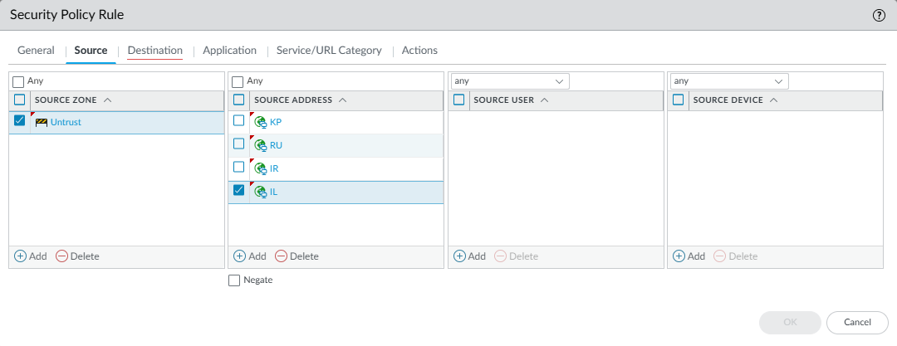

Destination Tab:

Destination Zone: HR_Zone, IT_Zone, Sales_Zone (Depending on firewall)

Destination Address: any

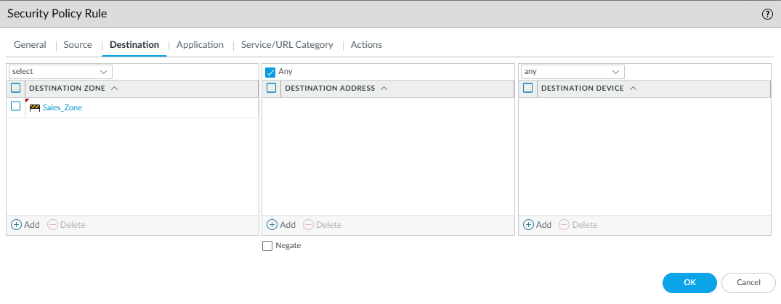

Actions Tab:

Action: Deny

Log at session start: Enabled

Log at session end: Enabled

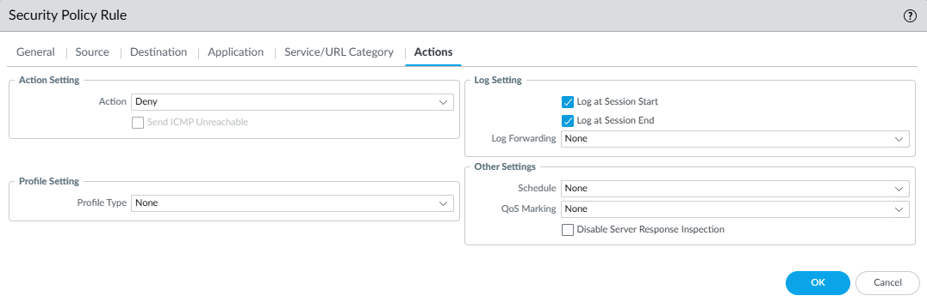

# Conclusions and Recommendations

Our firewall implementation used a multizone Palo Alto network configuration to control and monitor the network access of the Sales, IT, and HR departments. We used a variety of different Palo Alto firewall features to carry out the tasks set in the assignment brief. Our configuration involved using multiple interfaces and security zones, with one of each assigned to each department, and an internet-facing interface to allow internet access to the computers in each department. Application-based policy rules were used to prevent employees from accessing prohibited apps, while allowing specifically IT department employees to access online storage services. We used decryption-based policies to permit URL inspection and the filtering of traffic using threat prevention profiles and a VPN tunnel was created to allow PCs in the SG and KL subnets to remotely access each other.

In the future, we could document and clearly label the functions of each rule on the firewall that we made for easier understanding. In some cases, there were instances where traffic was being incorrectly recognised as the wrong application, causing some traffic to be mistakenly denied by URL filtering rules. Some rules also do not log any traffic, making auditing logs harder and making it more difficult to troubleshoot traffic rules. In addition, in future projects like this one, we could add a message with each saved version of the configuration file to make it clear what changes were made from one version to the next. The online storage service rules use explicitly list applications instead of using URL profiles, which could have been improved upon to allow PCs in the IT department to access more storage services.

The security of the firewall configuration could be improved by altering the block_unapproved_apps rule to log both at session start and end, providing more visibility into dropped traffic and allowing for easier threat detection and troubleshooting. We could also include User-ID to restrict application access to users within the same department, e.g. only allowing access to certain services with important information to IT administrators. Some rules within the configuration may not ever be matched due to other rules above them filtering more broadly, meaning that traffic that would match the rule always matches a rule above it, and removing them would help improve network performance, and some rules, like the DNS and Web Traffic rules, could be consolidated to reduce policy overlap.